Imagination, design and innovation, going beyond commerce

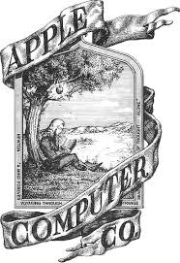apple

Design and privacy

One of the best manufacturing companies for tech

We believe that we’re on the face of the Earth to make great products

Byte into an Apple

Apple

Beautiful, effort invisible

No tech talk, build anticipation

High rank with competition

Sleek, high quality

Loyal customers

Self-expression and creativity

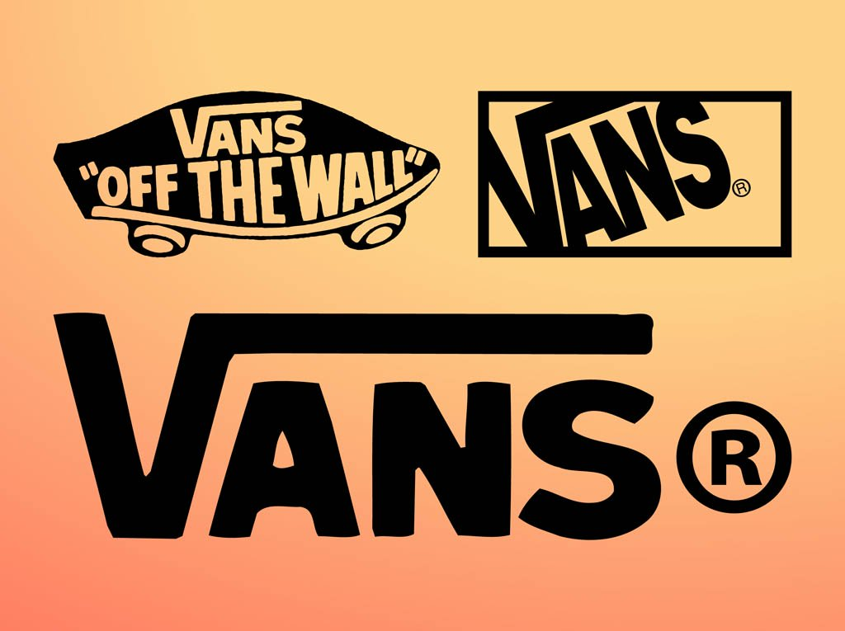

embracing creative self-expression

Number 1 skate shoe.

More than just delivering great products. Self-expression through youth culture by promoting sports, music, art etc.

“Off the Wall”

Vans

Checkerboard, comfort, casual

Colloquial, understandable for young people

High rank with competition

Determined, connected, inclusive and fun

Loyal customers