Asset Design research and progress
I have been tasked with researching and creating assets for my game, in this document I will record my research and progress over time.

Asset design research
For our game I will need to create Icons for items/the items themselves, I have used concepts from google to aid my research and creation of these things, below are some examples:
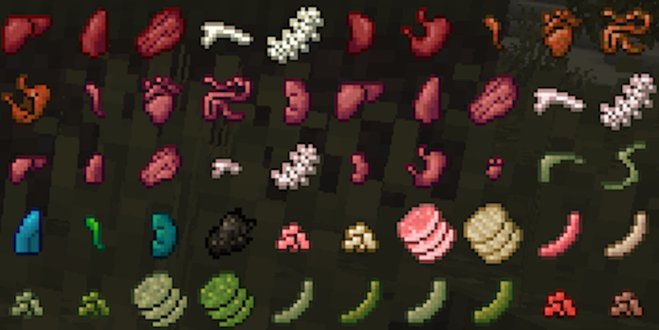
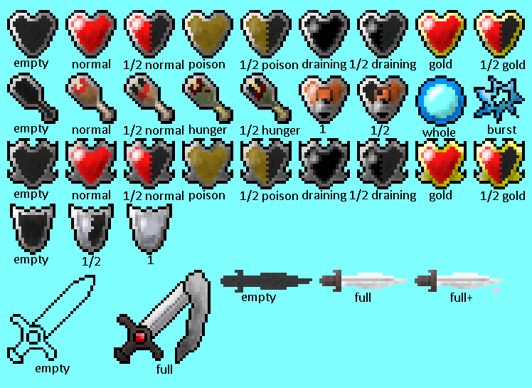
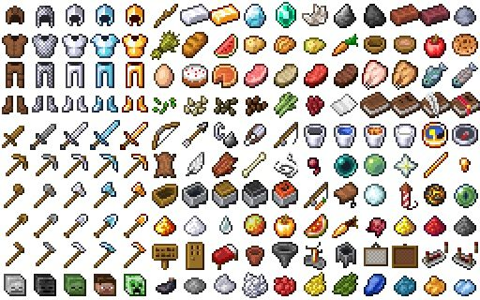
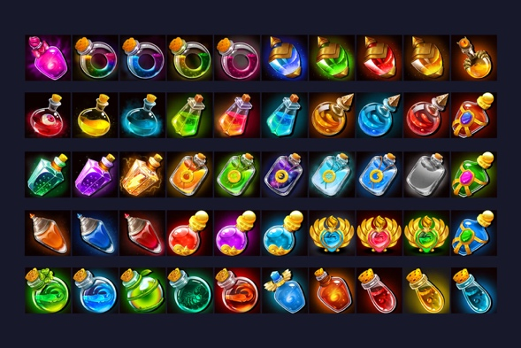
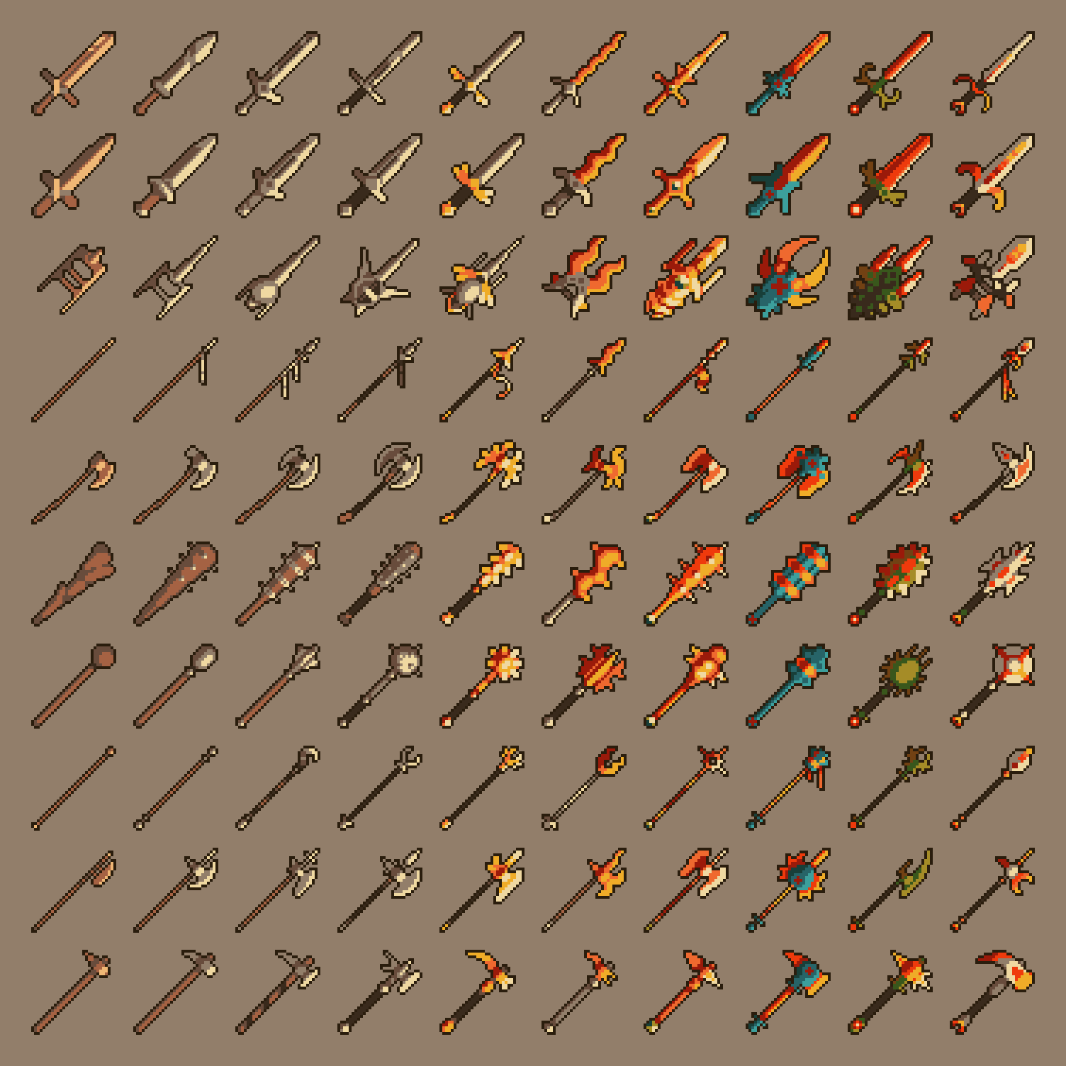
As you can see by these concepts, our idea revolves around 32-bit icons and is inspired by games such as Minecraft, Terraria and Darkwood…The idea is for the game to be top-down 3D with 32-bit icons for things like weapons and healing items

