Zodiac sign items



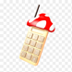Air sign

* Aquarius – Add 5-10 on their next roll/ Take away 5-10 on your dice
* Gemini - Can steal coins or items from an opponent / Your coin will be taking away
* Libra – A item that can summon allies / Can take away one of your allies

Fire sign

* 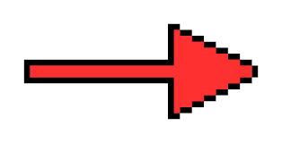Leo – Can add coin to their total that match their roll / Lose the same amount of coins from your dice roll
* Aries – Can hit an opponent to miss a turn / Makes you lose a turn
* Sagittarius – Their can see where the star is on the map/ Lets your opponent see where the star is.

Water Sign

* Cancer- Their can use a poison on their opponent which lets them take away -5 from their next roll / take away -5 for your next roll
* Scorpio- Their can turn into their evil side and take a certain amount of coins/ Lose half your coins.
* Pisces – Their can use their psychic power to take stars or coins from their opponent. / Your opponent can choose either coins or Star to let you lose.

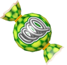Earth Sign

* Taurus- Their can take 1 star from their opponent / Lose one of your star
* Virgo- Their can teleport to their opponent/ You be teleport to the start
* Capricorn – Their can become small and take the opponent candies. / your opponent can choose one of your candy to be taken away

Key

Purple – Negative

Not Purple – Positive