Mythology folklore

*Kuchisake-onna (Slit-mouthed woman)*

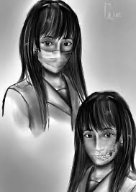

In 1979 their where an urban legend about a lady called Kuchisake-onna who was always asking children “I’m a pretty” and if the child says yes, she will come closer to the child and asked the same question and if their say yes again she will cut you just like her scar, but it also says “you look OK” or “So-So” she will be confused so you can get away and it also say some Japanese candies will also distract her.

*Futakuchi-onna (two-mouthed woman)*

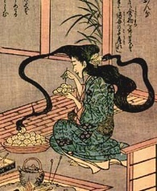

Futakuchi-Onna has a couple of stories like an evil stepmother who give a lot of food to her daughter and never a food to her stepdaughter which the stepdaughter grew sicker and sicker until she dead from starvation, then after 48 days the evil stepmother felt a terrible headache. The other story was a miser wife was not eating and then one day the husband pretended to go to work so then he could spy on his wife and then saw something terrible he saw his wife hair split one and saw another mouth who was scoop up rice balls and the mouth was crying out in pleasure from the food, then he left his wife and went somewhere the Futakuchi-onna couldn’t find him.

*Rokurokubi – (Long-necked women)*

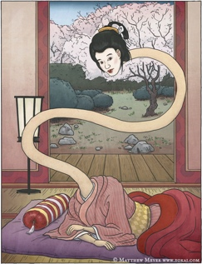

This yōkai are former a human- that transformed by a curse resulting from some evil or misdeed. In so many case their husband or fathers that committed the sin by in the some of the twist of fate the women only get affect and the male get way from the punishment. But the legends say that one of the lord servant girls was a rokurokubi some he spies on her to find out she was a rokurokubi. So the next day she was fired and fired from every place subsequently worked and she never ever know she was an rokurokubi.

*Irish/ Celtic folklore*

The fairies – (Living all around us)

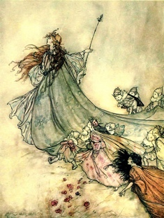

The fairies are one of the best Irish myths/ legends, the fairies are said to be living in “cnocs agus sibhe” but in Irish, this means the mounds of earth, which are be ruled by a king or a queen. And if you heard in Celtic myth of a banshee, were written in Irish as “bean sīdhe”, which is known as the “fairy woman of death”. It’s also said that if you hear her scream then someone will be close to death or already dead and she cries to warn the family of an upcoming death.

The leprechauns – (the most famous little people)

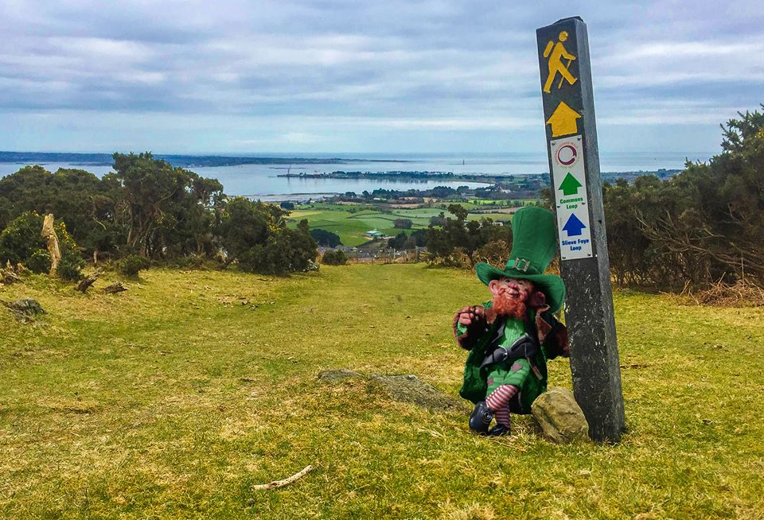

Leprechauns or “Leath bhrògan” are the cultural symbol of Ireland, which their name means ‘Shoemaker’. They were said to roam the Ireland before humans with their iconic unique hat and red hair. There is an oral tradition, where you can find their pot of gold at end rainbow but keep in mind that Leprechauns are not be trusted

The Dullahan – (the terrifying tale of the headless horseman)

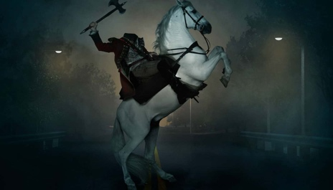

This fairy is known in Irish mythology and a folklore as the headless rider that rides on a black horse, carrying their head in their arm. He was said to ride fast through the counties of Down and Sligo, and if he suddenly stooped, its mean someone it that community was about to be due to die and this myth have given Johnny Depp who played a character in ‘Sleepy Hollow’

The Banshee

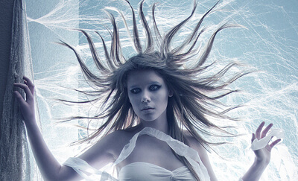

This is a female spirit who is from the Irish mythology, a banshee who can appear in so many forms. She can be an old woman with some frightening eye, a pale lady in a white dress and then a beautiful woman who is wearing a shroud. Regardless how the banshee looks, her wail can send shivers up people as it a signal to someone impending doom.

Bánánach – (Irish Demons)

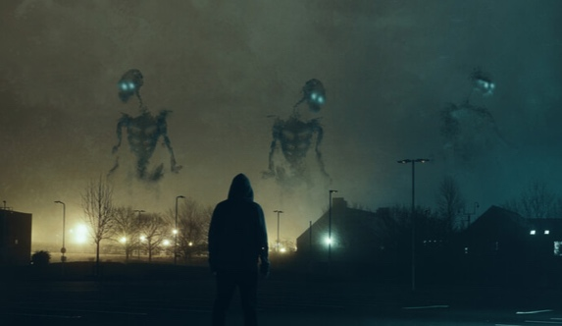

The Bánánach are Celtic monster that haunt the battlefields that are associated with violence and death and their also have the appearance are the goat-like.

The Merrow

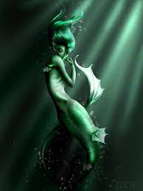

The Merrow who are Celtic mythology creature which the best to be described as a mermaid in appearance, however their can go on land or at the depths of the ocean. The merrow said to be friendly and modest and it also said to be half fish (from the waist down) and a beautiful woman ( from the waist up)

Fear Gorta

