Minigames

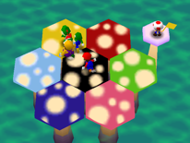4- Player minigames

1. Simon said – the players have to go to the clovers that the Leprechaun said.

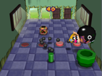

1. Steal the Dust- the players have to sneak to the fairies to steal their pixies dust

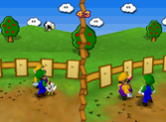

1. Catch the pot of gold- the players that to get the pot of gold from the Leprechaun.

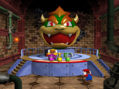

1. Stay out of sight – The players have to stay out of Medusa sight because she will turn you into stone (battle minigame)

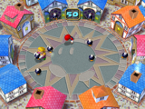

1. Siren song – Players need to dodge the music note when the siren are singing.

2-Vs-2 Minigames

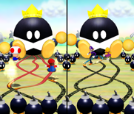

1. 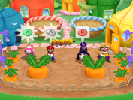Fairies can be dangerous– The players have to try and put out the fairies’ wands before their get to the queen or the mother of the fairies
2. Radish takes over - Players have to pull out a Radish out of the ground

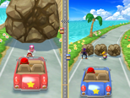

1. Road Rage – The Player has to Break the rock on the road to win

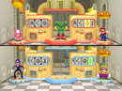

1. Creator Creation- The players have to create a creature that the minigame says.
2. 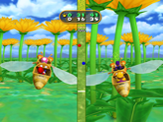 Flower Fall – The players will have race on a flower to the finish

1 vs 3 minigame

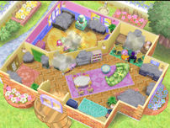

1. Cleaning Lake -All the players have to clean the Lake; the one person will have the biggest clear whilst the 3 players have smaller clear.

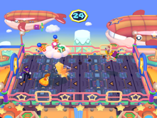

1. Dodge Zeus lighting - 1 of the players has to shoot lighting from the cloud whereas the others players have to dodge the lighting

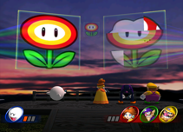

1. Imperfect Pictures – All the players have to match the picture that’s is shown on the smaller picture like (Mermaid, Leprechaun, Lock Ness Monster etc.) (time limit for each image is 25 seconds)

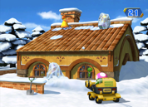

1. Jake Frost attack – The single players will have the powers of Jack Frost and trying to hit their rival’s player off the roof of a house with in the time limit (30 seconds)

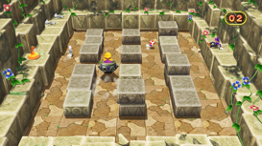

1. Sea attack – One of the players will be in a ship and trying to get the other players and the sirens to win and there is also a time limit (45 seconds)