Characters

Leprechaun – Will be in some of the minigames

Fairies- Is a playable character and also in some of the minigames.

God – Will be in some of the minigames (Zeus)

Sirens – will be in some of the minigames

Spirits- some of the minigame (Jack Frost)

Mermaid/Merman – Playable character and in a minigame

Lock Ness Monster – is in a minigame

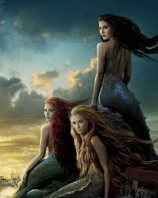Zodiacs – Can be played can on the playable character.

Yõ-Kai – Playable character and in one minigames

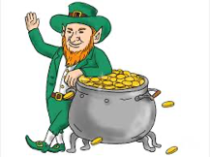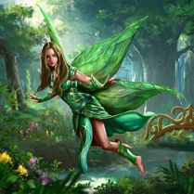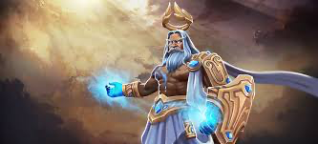

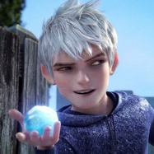

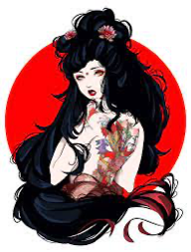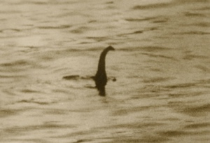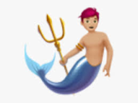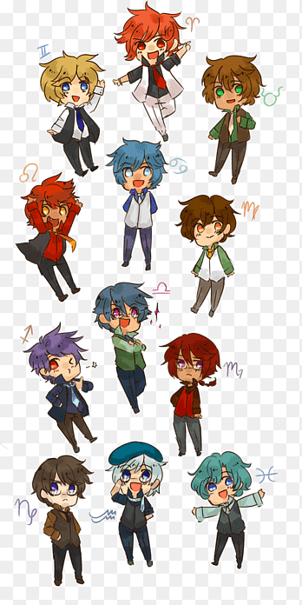

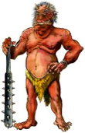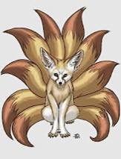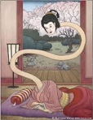

Playable Character

Zodiacs

Mermaid

Yo Kai

Fairy.