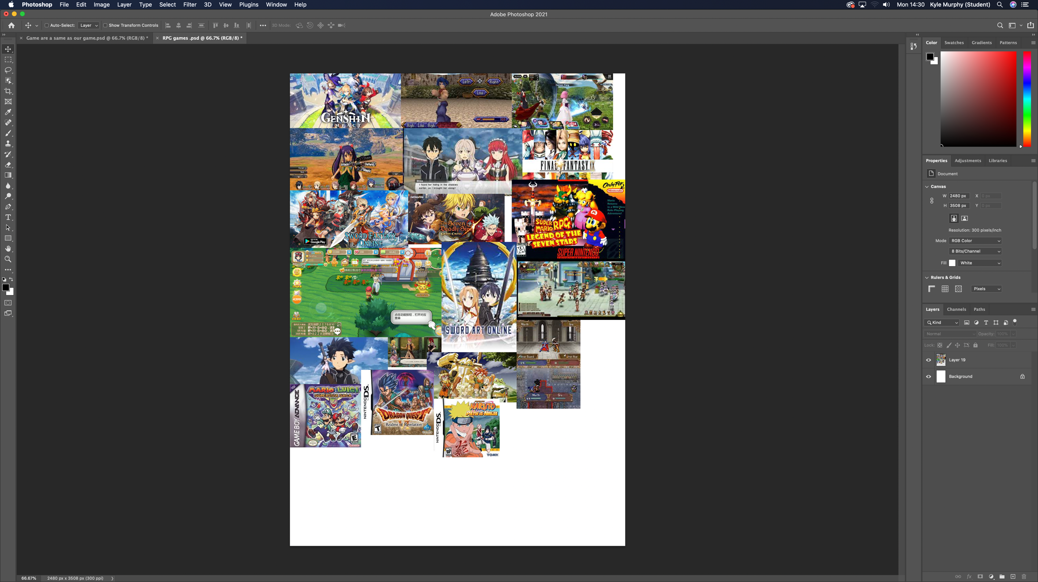

RPG games

This mood board is about our theme of our games open world RPG games so I looked up a lot of pictures of RPG games or open world RPG games like Sword Art Online, Super Mario RPG, Fairy tales, Fire emblem, final fantasy, 7 Deadly Sins, My Hero Academia.