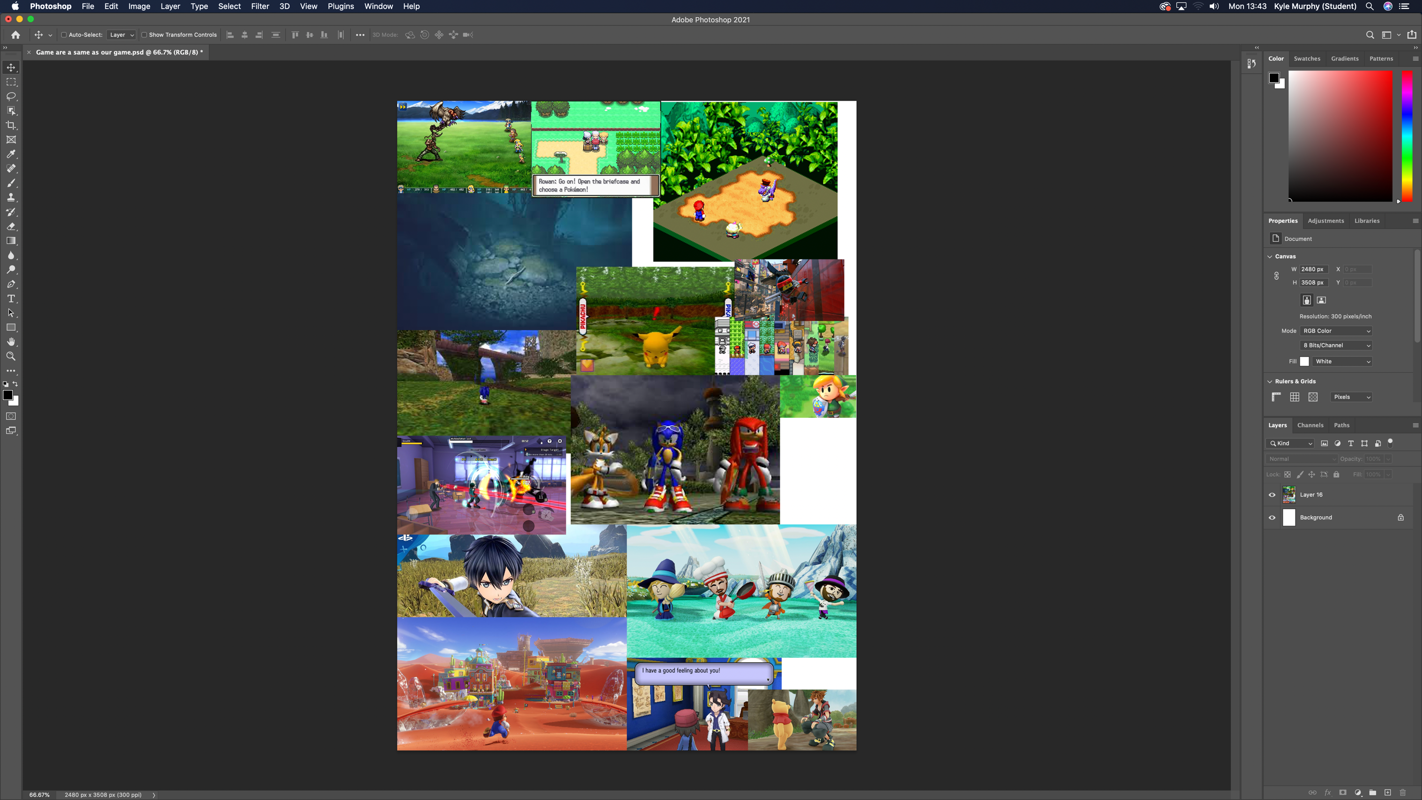

RPG and Plains mood board

These pictures I choose for this mood board is the plains and everything that have plains look atmosphere like Miitopia, Mario Odysseys, Sonic, Link, Pokémon, MHA and Final Fantasy. And also RPG is our games design.