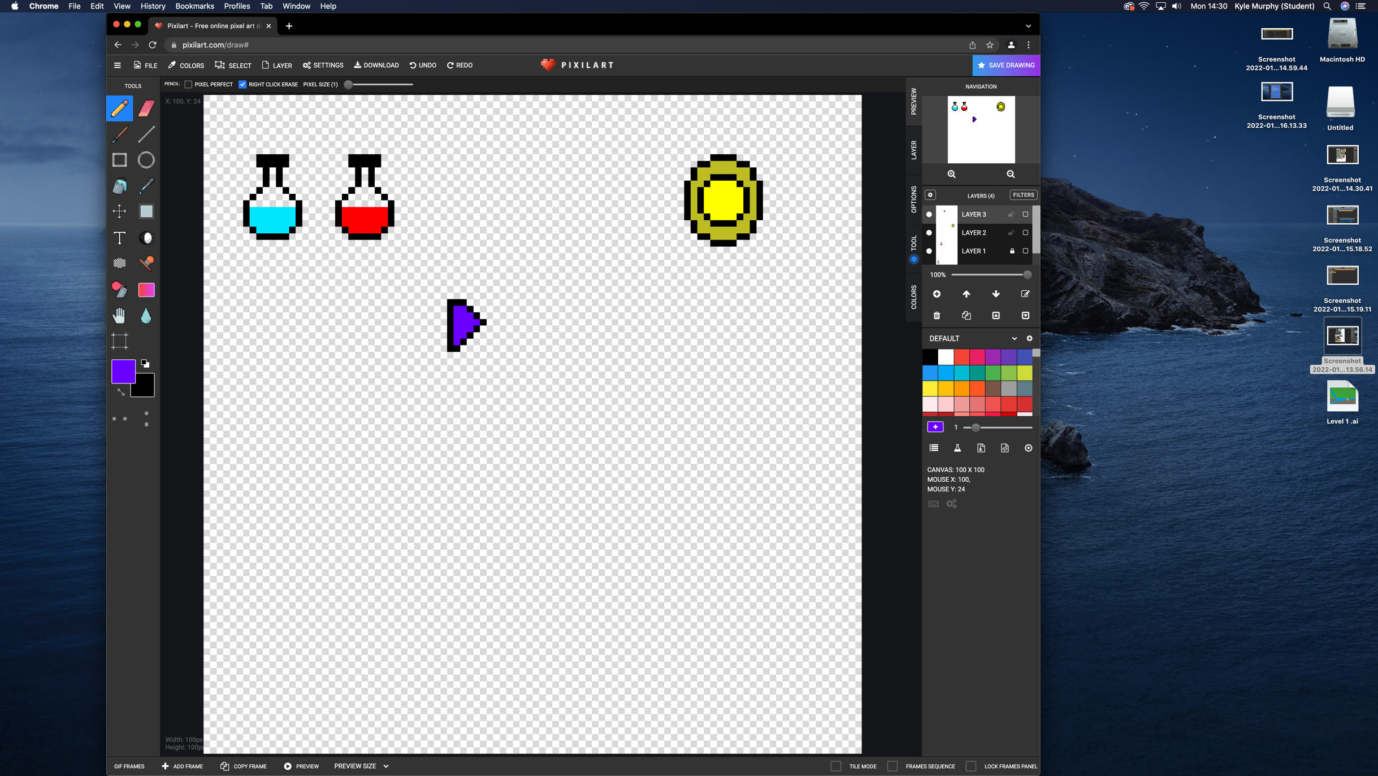This is a drawing of a health potion, Mana potion, a coin from the game and the players icon