Research about LGTBQ

The LGTBQ+ stand for Lesbian, Gay, Transgender, Bisexual and Queer and it also included Pansexuality etc. And in the 1970’s Gay became the popular term in the USA, In the 1969 Stonewall riots in the NY city, and in the late 1970’s and the early 1980’s, some gays and lesbian became less accepting of Bisexual and Transgender people. And in the 1990’s the USA the LGTBQ+ people get some respect.

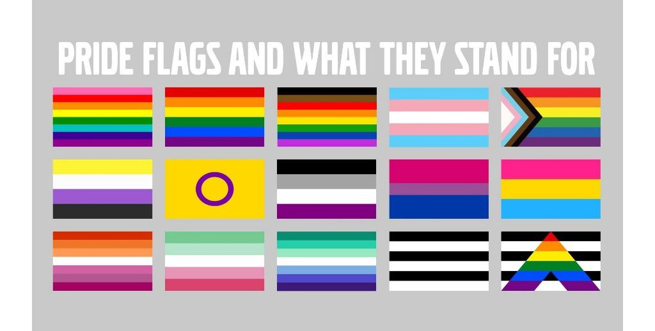

There are the flag that are represented of these flag

Transgender Flag


Transgender Flag

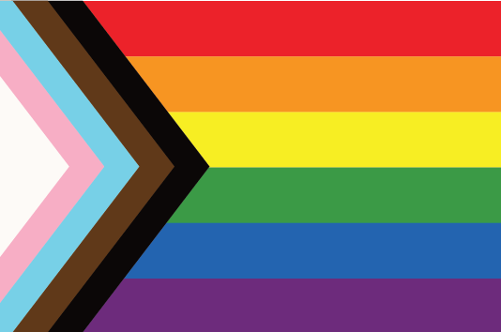

Progress Pride Flag

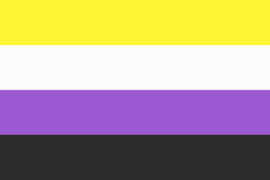

Nonbinary Pride Flag

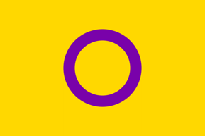

Intersex Flag



Asexual Flag

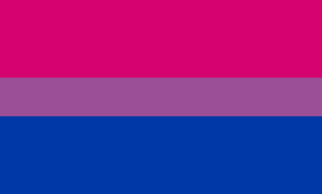

Bisexual Pride Flag

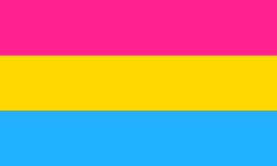

Pansexual Flag

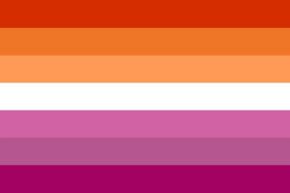

Lesbian Pride Flag



Gay Men’s Pride Flag



Heterosexual Pride Flag

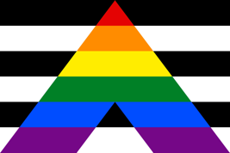

Straight Ally Flag