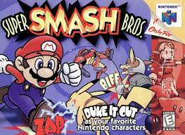Game Analyse – Super Smash Bros N64 Nintendo

Date: 21st January 1999

Roles:

* Spirit writer to help with the story of the game – Story broad for the intro of the game and who the characters are placed
* Voices actors for the lines in the game like e.g Mario, Luigi, Master Hand, Announcer, Yoshi, Link, Ness, DK, Captain Falcon, Fox, Pikachu, Jigglypuff.

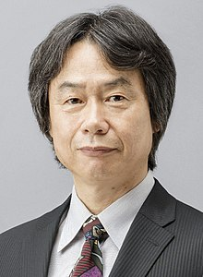

* Level designer- what the levels are going to play, and the items in the game
* Characters design – the are a lot of character building like the mapping of the characters attacks, movement, character victory screen

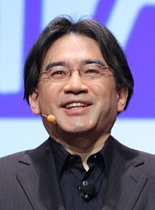

* The Producers – who overseeing the development of the video game and for the smash bros N46 producers are Hiroaki Suga, Satoru Iwata, Kenji Miki, Shigeru Miyamoto
* The Programmer- is the software engineer, the programmer, or the computer scientist who is the primarily develops codebases for the video game and the programmer for Smash bros N64 is Yoshiki Suzuki
* The Artist- job is to create arts for one or more types of games like role-playing, collectible card games and video game, and the all the aspects of the game development which is call visual art, and the artist in smash bros N64 is Tsuyoshi Wakayama
* The Composer- Is main role of creating and producing video game music requires with a strong team and coordination to make the music in the game and the composer of Super smash bros N64 is Hirokazu Ando

Nintendo got the feedback of this game to make the game look better like in the new version of the game is Super Smash Bros Ultimate for the Nintendo Switch

