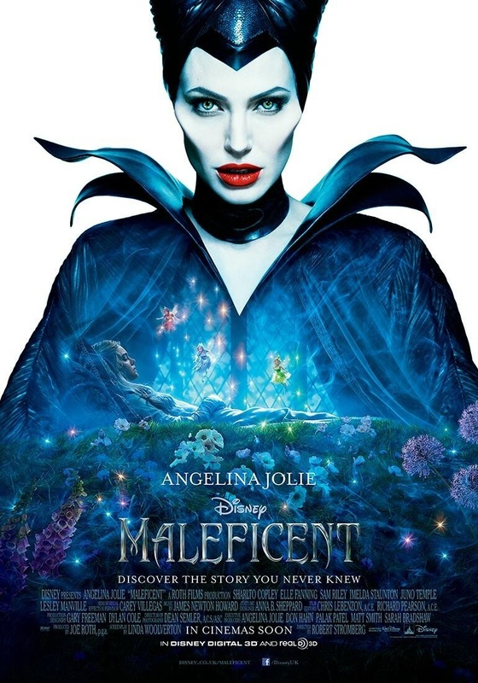

**Maleficent Movie –**

Colour: The blue is representing the sadness about the character dying and the princess was cursed to go to sleep and never waking up

Image: The image is representing about the about good and bad, Maleficent is representing as the bad guy and Sleeping Beauty as the good guy and never trust people who horrible people and don’t always trust the good guys as well

Type: The type of this film is a princess that was curse by someone to go to a deep sleep when she is 16 years old and the princess in this picture that she was hurt by someone that she trusts, and the woman is the background showing that people can change.

Idea: The idea about Maleficent that the good guys can bad and the bad guys can the good that why Disney did what they’re too maleficent to that someone who is evil and bad can actually be good and hurt by someone who hurt her in the past.

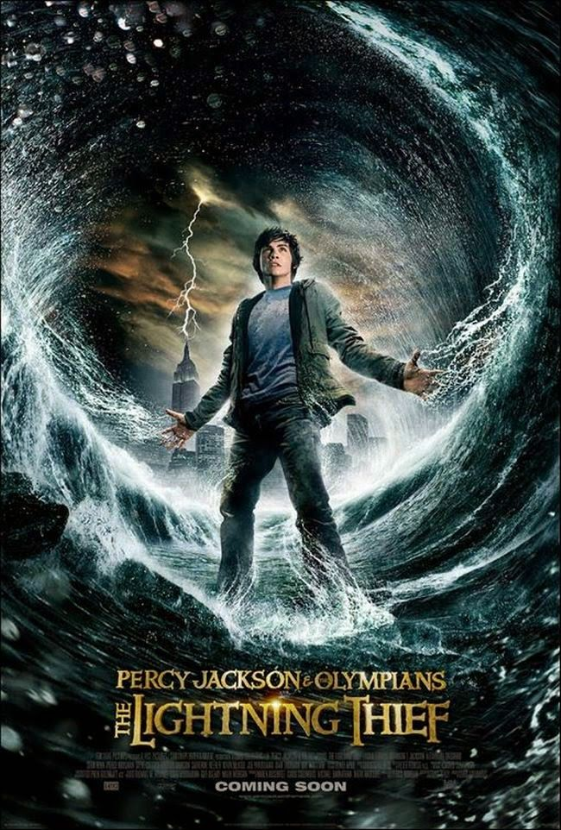

**Percy Jackson-**

Colour: The colour of Percy Jackson is the blues representing that who can actually achieve your dreams and you can look like the leader of what you are doing, and the yellow is the different we the sky’s and the lighting are opposed to the blue which yellow are like happy, childish.

Image: The image is representing of the son of Poseidon Percy Jackson who have the power of the sea and was accused of stealing the lightning bolt of the Zeus. And Percy is just a teenager who went to on. A quest to save his mother and give Zeus his lightning

Type: the type of this film is a fantasy and is about the Greek gods who had children and not getting to see them because of the rule that Zeus set what makes their children hating them but their helping them when their need it and Poseidon helped Percy on his journey

Idea: The idea behind the poster is that you can achieve your goals if you put your mind to it and letting the children of the gods see their offspring because some of the children didn’t know who their god parents where

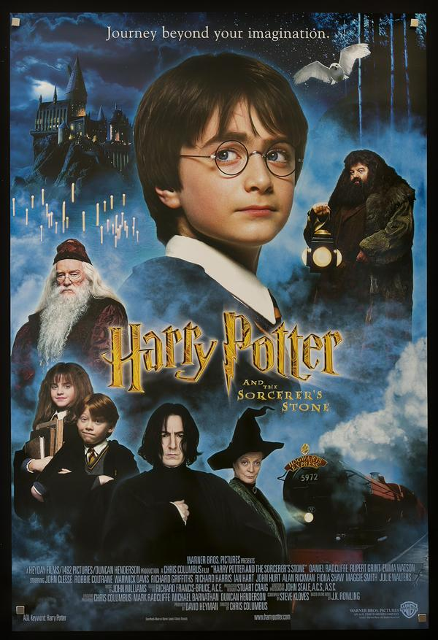 **Harry Potter -**

Colour: The colour of Harry Potter are blues, blacks and red to representing the mystic of the film, the reds are for the dangers that Harry Potter and his friends who go on and the blues are for scary and magical place that Harry is in and the white show how Harry is pure and the choose one.

Image: The image is a younger boy who parents you die when he was a baby but the lightning left by the dark lord