**Fantasy:**

Fantasy is a genre of that have creature magical and the supernatural elements that do not exist in real life and some of the sub-genre are dark fantasy, Superhero Fantasy, Action fantasy. The movie that are conventions of fantasy like The Witches, Percy Jackson, Harry Potter, Dr. Do-little and X-men. Ans some of the creatures that are link to Fantasy are Gods, Fairys, fae, chimera, elf, Banshee, Mermaid, Hydra, Dragon

<https://www.masterclass.com/articles/what-is-the-fantasy-genre-history-of-fantasy-and-subgenres-and-types-of-fantasy-in-literature#:~:text=Fantasy%20is%20a%20genre%20of,exist%20in%20the%20real%20world.&text=Speculative%20in%20nature%2C%20fantasy%20is,to%20reality%20or%20scientific%20fact>.

Movie:

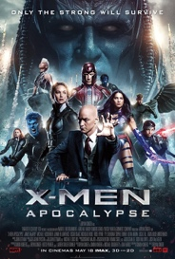

X-men

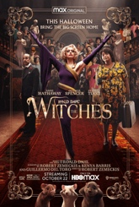

The witches

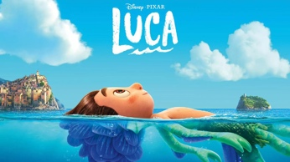 Luca

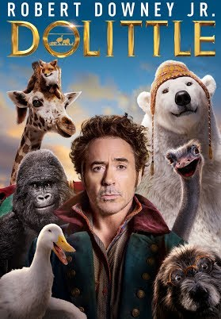 Doctor do-little

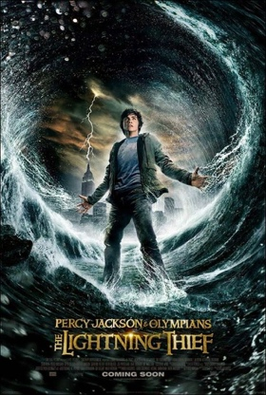 Percy Jackson

Creatures:

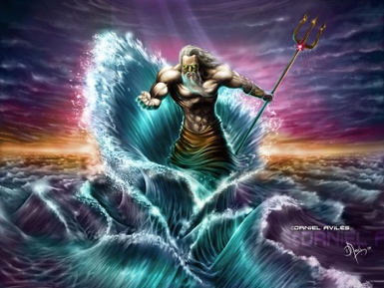Greek God of sea- Poseidon is a Greek mythology who is the god of the sea, storms, earthquakes and horses. Poseidon is one of the 12 Olympians gods, who is the brother of Zeus the god of Sky, Hades the god of the underworld, Demeter the goddess of harvest, Hera the goddess of marriage, Hestia the goddess of the hearth and his last siblings is Cheiron who is a Centaur.

<https://en.wikipedia.org/wiki/Poseidon>

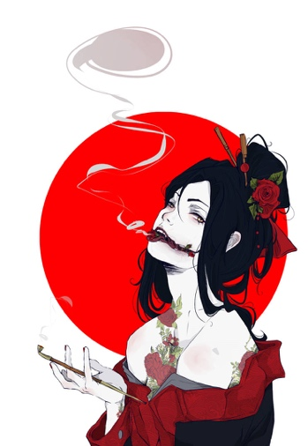 Kuchisake Onna- One they was an a beautiful women who was always asking people “I am I pretty” and they always keep asking that but one day her husband cotch her cheating so he got a pair of knife and cut her face open and he said “who will say your pretty now!” and then she die. And then she dead and then come back to earth then the police hear and the children at night have to walk together but if you walking alone a woman with a mask on and a trench coat on and she will ask you “Am I pretty?” and if you say “No” she will kills you with scissors, and then you say “yes” she will then take off her mask slowly and then ask you the question “How about now?” then you said answer “no” she will cut you in half and then if you say “yes” she will slits your mouth so it appears like hers. However you say “so-so” she will get confused and it gives you time to get away

<https://en.wikipedia.org/wiki/Kuchisake-onna>

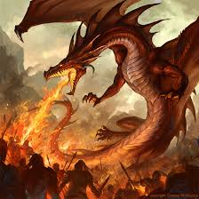 Fire Dragon

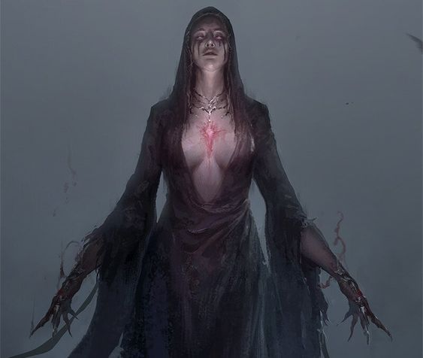 Banshee

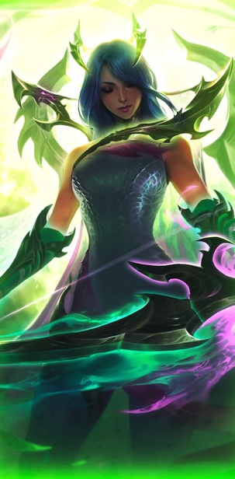 Fae

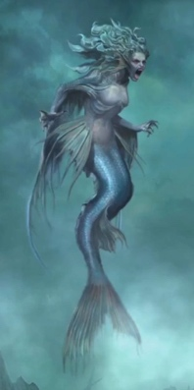

Mermaid