***Pocket Planet***

*What is pocket planet?*

Pocket planet are games that allow you to create anything you can think of. The theme could be anything from fantasy, sci-fi, or realistic.

I think of pocket planet as a game where you can create whatever it is you can think of.

***Minecraft***

Minecraft is an open world game with multiple options of gameplay to choose from. You can aim to defeat every boss in survival mode crafting and collecting items to achieve the goal or enter creative mode where you will have every item available to bring your imagination to life. And there are also online servers where there is a various selection of game modes to choose from, such as factions where you fight against other players and destroy their base in an open world. I think Minecraft is a fun sandbox adventure that gives many options of game modes other than survival or creative

***Deiland: Pocket Planet***

Deiland: pocket planet is a game where you start off standing on your own planet as a farming adventure. But you slowly build it up as character’s come to your world and after helping them land, they offer missions to complete, which could be building an item or defeating a certain number of mobs. I think the game is an educational game that teaches you the difficulty of farming as the seasons change.

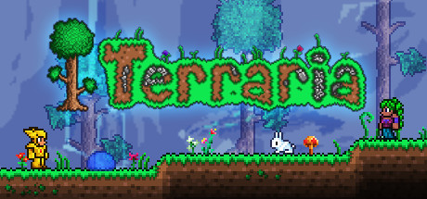

***Terraria***

Terraria is an action-adventure sandbox game like Minecraft where you start off with nothing and build, craft, and explore to progress. As you progress and defeat bosses the game changes its difficulty getting harder as you progress and adding more weapons and environments. I think the game is a fun sandbox adventure game, while getting more difficult the farther you get.

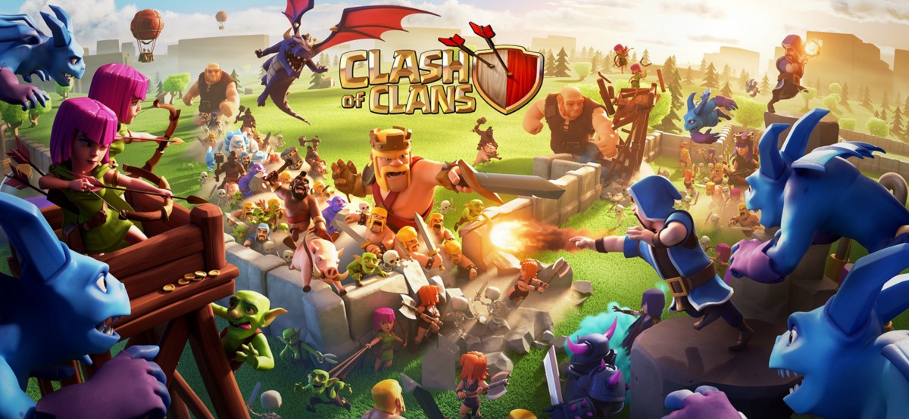

***Clash of Clans***

Clash of clans is a game where you start off small, as your tasked with building up your base and acquiring more soldiers. The goal of the game is to attack other players bases while also building your own up, making It harder to destroy by upgrading building and acquiring many soldiers with different skills such as an archer, swords, or mage.

***Conclusion***

Pocket Planet in terms of genre is vague as it can be many different things. It can be building anything within a city, understanding elements, evolution, farming, or all of them in one in games like Minecraft or terraria.