***Title***

The title is a creative combination of the land and cave textures

***Textures***

The textures in the game are realistic while also having a design as if the player is within the forest

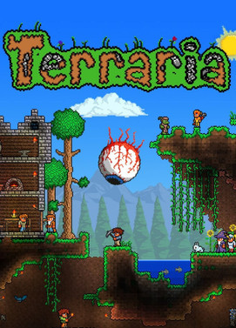

***Animals***

There are both fantasy and realistic animals in this game, which you can tame and take as pets which you can mount to get to locations quicker.

***Enemies***

The enemies design in this game are more gruesome indicating that the games demographic is more towards ages teens and above.

***Character***

There are both fantasy and realistic character design in this game allowing the player to customize and pick what design they’d like

***Health***

Keep track of health in this game is important as it will tell you how close the player is from death.

***Dungeon***

Dungeons are a locations players can go to defeat bosses and take the items within chests to help complete the game.

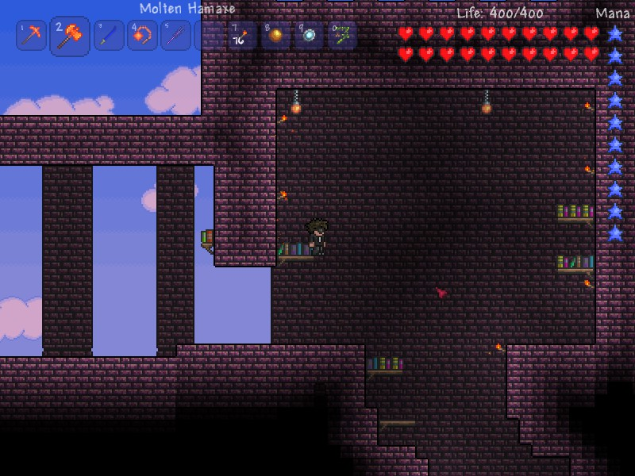

***Mana***

Mana is the amount of magic the player can use; it helps give more damage when using magic weapons against bosses.

***Inventory***

Inventory is where your store your items, the numbers on them is to quickly switch between each item by clicking the same number on the keyboard.

***Goal***

The goal of the game is to defeat every boss. After defeating the final boss on easy the difficulty is raised, new enemies and terrain spawns and this continues until you’ve defeated all bosses.

The player can also set a goal for themselves such as collecting every item within the game or building an entire city based on a design or their choice.

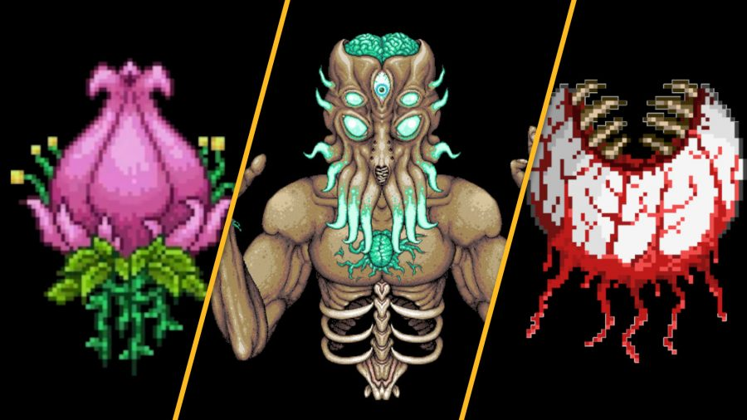

Conclusion

Terraria is an amazing game, with increasing difficulty and many customizable options. It has been around for almost 11 years and still popular with a community that made many mods for the game to choose from.

I think the only thing wrong with the game is because of it being 2D the building you make can’t be as complex as a game like Minecraft. but in terms of its adventure content, I think terraria is better than Minecraft in that as it has more bosses and content within it.