PlayStation 4 box cover reflection

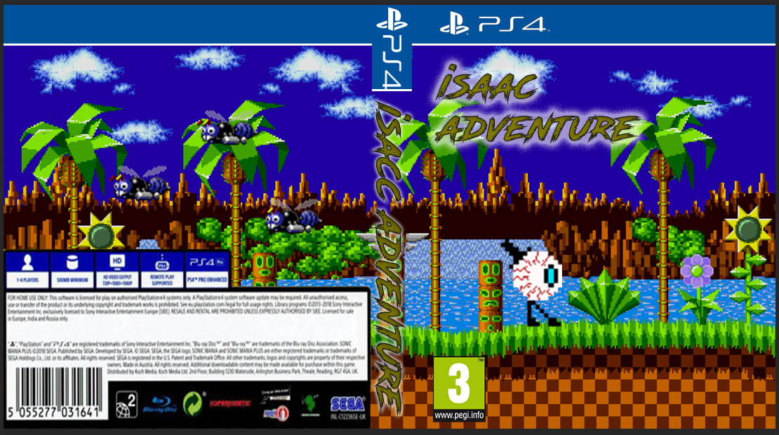The class was given a task to created a game box art that of a game in photoshop so with that in mind I wanted to create a simple design and try to not make it too complicated so I went with this design.

This is the complete work of the box cover and I believe that it turns out really well considering that I only know a little on how to uses photoshop so I believe this is the best possible work I can produce

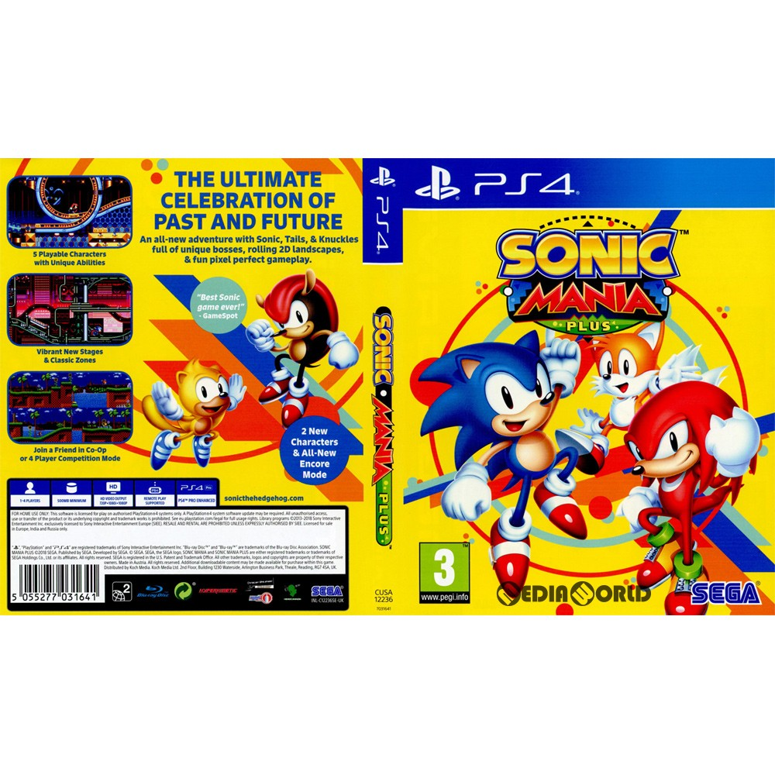

This is the box cover that use as a reference while I was creating my game cover.

Link of the image

<https://global.rakuten.com/en/store/mediaworldkaitoriworld/item/10441094001/>

I first started with a PlayStation 4 (ps4) box cover then use the ruler tool to line up the most important part of the box cover like what goes where and other important aspect.

First, I started with the blue boxes on top with using the tool that can created boxes and when I had a box size that I was satisfied with I use the paint tool can colour the box in and I did the same method with the white bar.

Tool I use

The next thing that I forces on was the back ground and I chose a pixel style of level as I believe that will be more interesting so I chose a wallpaper from the classic game sonic

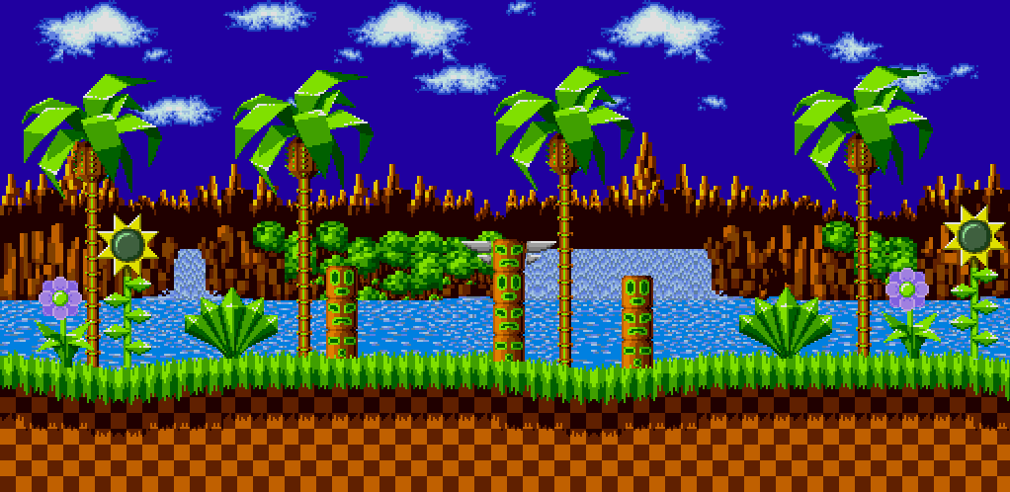

Link to the image

<https://www.deviantart.com/sonicmechaomega999/art/Green-hill-zone-background-595461165>

I like how the level look so I thought it would look nice to have this as our wallpaper of the game cover.

The next thing that I focus on was the ps4 logo as all ps4 game cover all have one on the front cover.



Link to the image

<https://ya-webdesign.com/explore/playstation-4-logo-white-png/>

I got a png of the ps4 logo and then did my best to link the logo up to the ps4 cover I was working off on then when the logo was line up to a way that I like I press Ctrl + U to increase the brightness of the logo to make it the same as the logo.

Then I made a copy of the logo a sperate the words and logo and then place them on the spine inside the blue box.



Link to the image

[https://www.nintendo.co.uk/Support/Parents/Safety/Nintendo-3DS-Parental-Controls/What-can-I-restrict-with-Parental-Controls-/What-can-I-restrict-with-Parental-Controls--907332.html#](https://www.nintendo.co.uk/Support/Parents/Safety/Nintendo-3DS-Parental-Controls/What-can-I-restrict-with-Parental-Controls-/What-can-I-restrict-with-Parental-Controls--907332.html)

the next thing I focus on was the pegi age so I went to the link above to see what kind of pegi that I like and I have chosen pegi 3 as the age range.

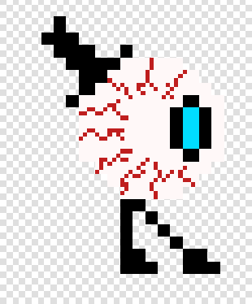the next thing I did was the character so I created a pixel character using the website piskel where anyone can create our own sprites the way there please.

the image on the left is a sprite that I created then

exports this as a png then put the sprite on the cover.

Link to the website <https://www.piskelapp.com/>

After that was done I then went to google then download a text style that I like and put the download file in fonts so I was able to use it and when I was able to use it I decided the name “Isaac adventure”

And the reason on why I chosen that name was because the name Isaac sound like eyes so it like a pun and when done designing the name and placement and made another title with the same name and put it on the spine.

Link to the text style

<https://www.1001fonts.com/search.html?search=road+rage&x=7&y=7>

after that was done I decided to add some enemies so I went with some of sonic enemies to fit the theme of his back ground.

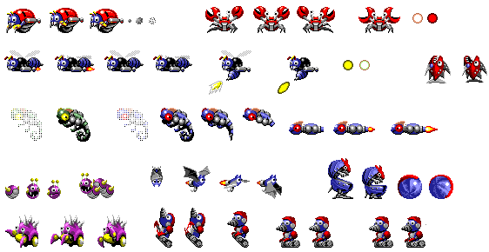

This is some png image of sonic enemies so I decorated the back of the game cover with one of the enemies.

Link to the image

<https://ya-webdesign.com/image/sonic-1-sprite-png/1760858.html>

then I finish the box art with the box of the back and how I did this is with the ps4 cover that I was working of so I got another copy and crop the image in photoshop save the image as a png a stuck it at the back of the box cover.

what I like most about the work is the simple design and the think I would improve is the sprite that I created as it does not really fit the scene.

If I had the chance to redo the box art again I would like to not make it pixel and like to make it more life like or realistic.