**Comparing the different artist styles of propaganda during WW2 and how both sides manufactured and created propaganda.**

This essay will be comparing the Axis and the Allies artistic style of propaganda which will compare a variety of artistic styles from the use of font to the message it is trying to evoke.

From the start to end of the war, propaganda played a vital role in helping motivate civilians. This can be seen in propaganda made by the United Kingdom ministry of defence with posters such as “We beat em before and we’ll beat em again” (image 1) in big bold text to grab the attention of everyone that walks past it. This poster also has an image of another German soldier in the background surrendering. The poster is referring to the United Kingdom’s victory over Germany in WW1, this is significant as the people of Britain needed a moral boost to help them and this would remind them that all hope is not lost, this may motivate the public as it reminds them that their hard work and effort will pay off.

Another propaganda poster from the United Kingdom ministry of defence is Lord Kitchener “Your country needs you” (Image 2) this also may motivate people and inspire them to join the military because the “You” makes it feel personal to the audience reading it. A journal published by the Scientia militeria suggest that the “YOU is emphatic” (Chambers, 2012). The United Kingdom did not produce posters just to motivate its people but to also scare them as well. These scare tactics can be seen in the poster published by the Ministry of Health “Don’t do it, Mother – Leave the children where they are” (Image 3). The design of the poster uses stippling to great effect this can be seen with the drawing of the family and the city in the background whilst a sketch of Hitler can be seen the background. This poster uses scare tactics on mothers who wanted to bring their children back to the cities as it meant if they were to return to the city with their children, they are following Hitler’s order, this was significant at the time as well as children were seen as the future of Great Britain. Hitler is also seen on the poster, but he is sketched in to make the effect that he is there.

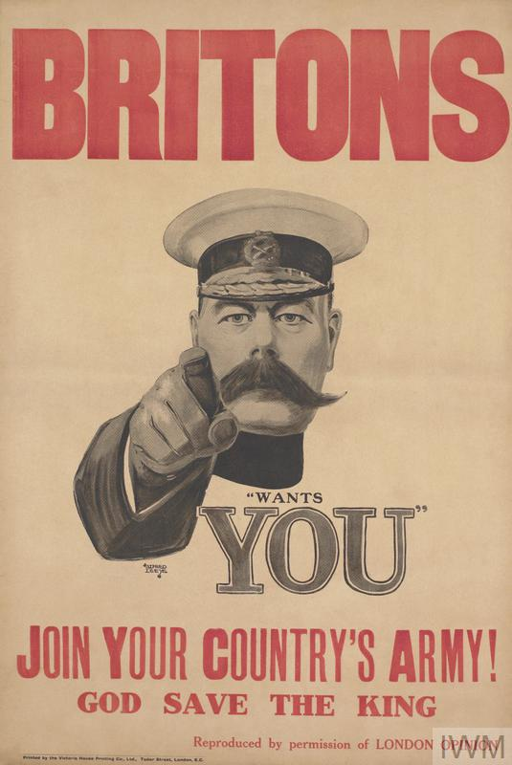

Image 3

Image 2

Image 1

On the other hand, American propaganda posters at the time focused more on the idea of being patriotic, as well as using cartoons on their posters this can be seen for instance, Mickey Mouse holding the American flag with the text underneath in red saying “Come on gang-all out for Uncle Sam” (Image 4). This poster also embodies patriotism as Mickey’s ears are blue and the text is red which is the same as the American flag, furthermore, Mickey mouse is also a well know character and a face for “capitalism”.

American WW2 posters also incorporated catch phrases to their posters, this can be seen in posters such as “Every time you twist a nut think of Hitler” (Image 5) the poster also included a drawn sailor that is using a wrench and twisting Hitler. This was an effective way of encouraging the American people to continue to contribute to the war effort by building ships. American posters also joked about the enemy within the posters as well. An example of this is the poster “Knock the Heil out of Hitler” (Image 6) this also continues to embody the patriotic side of the people following a similar colour scheme of red, white, and blue, the poster also features stars, which according to Scientia Militaria, suggest that the stars on the posters are from the “Star spangled banner” (Chambers,2012).

Another example of American propaganda is the poster “Uncle Sam” (Montgomery,1940) which according to the national archives was used in “rallying public support for the war” not only this but the artistic style of Uncle Sam is acrylic illustration. Unlike the British the American recruiting poster has Uncle Sam dressed in red, white and blue of the American flag compared to British recruiting poster where its Lord Kitchener this may have inspired American people who saw the poster to support the war as well as sign up because it possibly brought out the patriotic side of the American people whilst the poster is pointing at the audience and may make them feel like they should sign up for the army.

Image 4

Image 6

Image 5

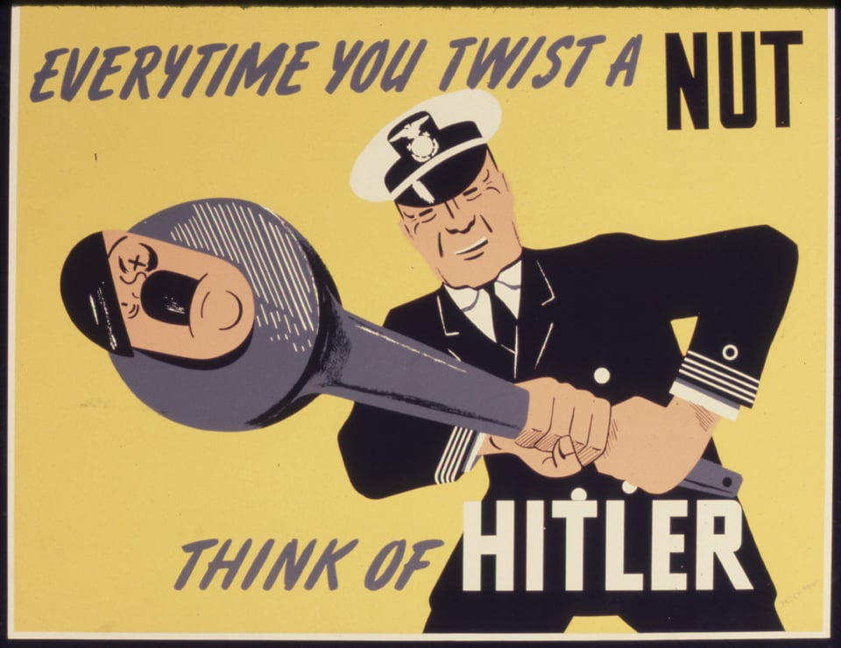

For German propaganda the German government turned to Joseph Goebbels and Ludwig Hohlwein, both artists had a different method in creating propaganda for instance according to The Peoples Profile “Joseph Goebbels had the responsibility of helping promote the government and would create posters with vibrant colours for example using red on the flag which would help promote the government colours. The colour red is significant to the Germans as well this is because its eye catching for the audience. Hohlwein however, had a different artistic style for example according to Spartacus education Holwein would “use a technique called acrylic illustration” (Simkin, 2020) he would use these to help promote the ideal German this can be seen on the poster “New people” (Hohlwein, 1938) where the use of vibrant colours is used as well as the darker colours for shade. The German Propaganda archive has a speech from Joseph Goebbels where he discusses the idea of propaganda and who to target this can be seen in the article “The important thing is not to find people who agree with me about every theoretical jot and tittle…winning people over to something that I have recognized as right” (Goebbels, 1928). As image 8, an SS poster from the Netherlands illustrates how powerful the SS was, the poster also had images of tanks planes and troops on it as well to encourage people to sign up to the SS and support the cause that the Germans were trying to instil on the occupied country.

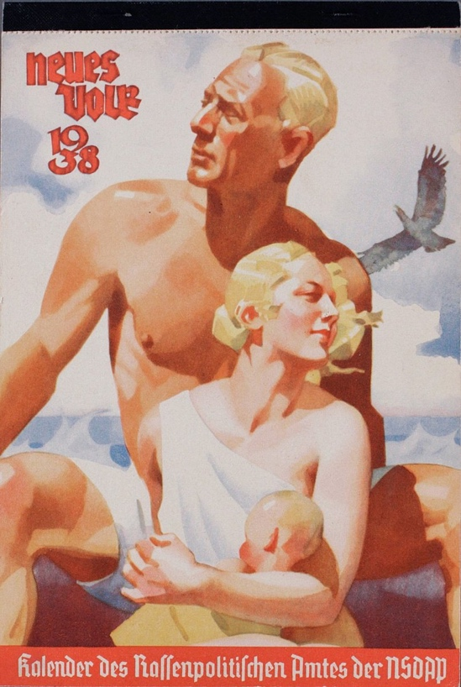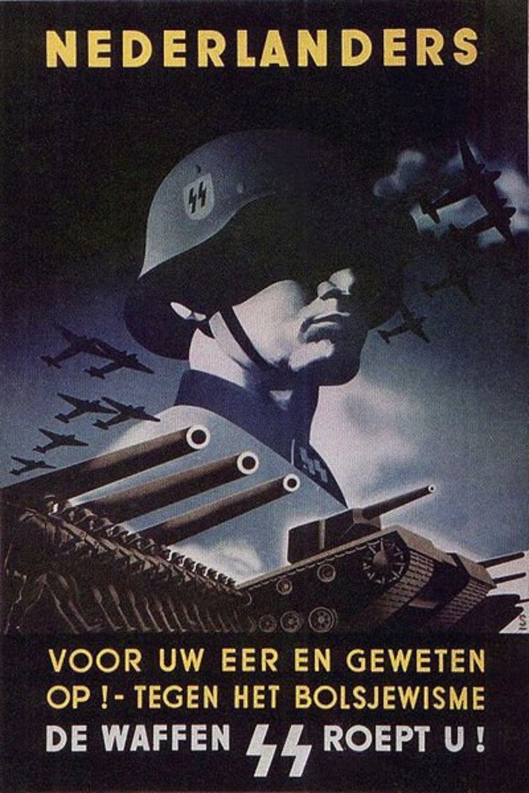

Image 7

Image 8

Russian propaganda on the other hand is different to both sides this is partly because the Russian people and the government didn’t trust the allies this can be seen in the poster “A united strike against the common target!” (Image 11) this in turn would also follow onto the start of the cold war. (Kurdov, 1943). The artistic style of the poster is sketch with a drawing of a fist with the ally’s flags on them as well this may have been to rally people and convince the Russian people to trust the other nations as well. In addition, the picture of Hitler with his hands covering his head may also motivate the Russian people to help the other nations as well. Another example of this, is the poster “The motherland is calling us” (Toidze 1941) (Image 9) this may have motivated the Russian people because according to the South African military journal “The female figure personifies the concept of Mother Russia” (Chambers, 2012). Whilst some Russian propaganda may have possibly motivated the Russian people other propaganda focused on the industry to encourage people to make more supplies for the war effort this can be seen in the poster “More metal means more weapons!” (Avvakumov,1941) (Image 10). The artistic style of the poster is charcoal this can be seen in the person with his arm out another artistic style that is on the poster is also stippling this can be seen on the drawing of the factory. This may have motivated the people to work harder in the factories as well as remind the people that they have to help defend their country the poster also has the Soviet Union symbol on the factory as well to remind the Russian people who they are supporting during the war.

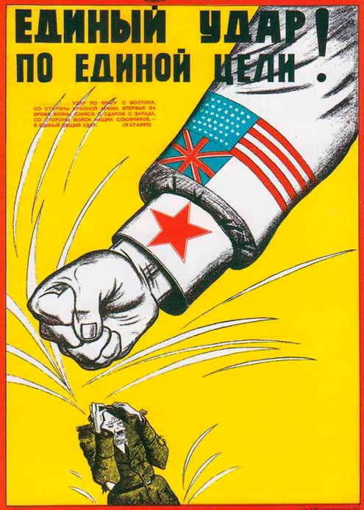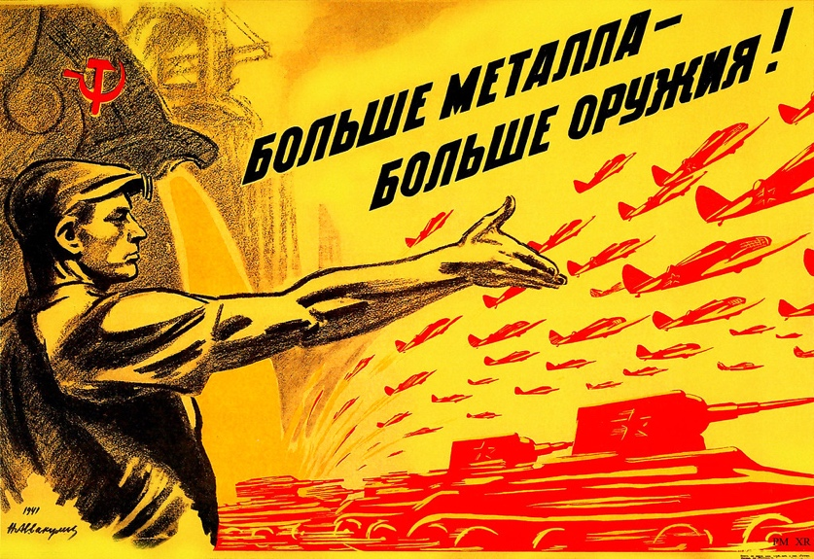

Image 9

Image 11

Image 10

In conclusion, Whilst the axis and allies both created different styles of propaganda the most effective artistic style came from the Americans thanks to using well known characters as well as embodying patriotism. Compared to Britain whose artistic techniques saw them use dull colours for example beige as well as using propaganda techniques to get the audience to fight for the king. Whereas Russian propaganda is focused on the people and tried to rally the people to fight for the motherland as well as rally the people to continue to build supplies for the war and used vibrant colours such as red and yellow. Furthermore, German propaganda used acrylic illustrate and bright colours to catch the audience attention, to make the posters more vibrant compared to the recruiting poster that the Germans had that used bold typography as well as dark colours.

Bibliography

Appreciate America, (1941-1945). Come on gang-all out for Uncle Sam [Online] Records of the office of government support. Walt Disney. Available from <https://www.docsteach.org/documents/document/appreciate-america-come-on-gang-all-out-for-uncle-sam-mickey-mouse> [Accessed 06/01/2023]

Imperial war museum, Tell nobody – Not even her! [Accessed 06/01/2023]

<https://www.iwm.org.uk/collections/item/object/31825>

Goebbels,J. (1928) Knowledge and Propaganda. German propaganda archive [Online] Calvin university. Available from <https://research.calvin.edu/german-propaganda-archive/goeb54.htm> [Accessed 11/01/2023]

Imperial war museum, don’t do it, Mother – Leave the children where they are [Accessed 12/01/2023]

<https://www.iwm.org.uk/collections/item/object/29088>

How Soviet propaganda glorified British – American successes in WW2, Let’s hoist the flag over Berlin,Russia Beyond [Accessed 12/01/2023] <https://www.rbth.com/history/330461-how-soviet-propaganda-glorified-british>

Irakli Toidze,The Motherland is calling you 1941 [Online],Agenda.ge. Available from <https://agenda.ge/en/news/2015/1016> [Accessed 12/01/2023]

Avvakumov,N. (1941) More metal means more weapons! [Online], Flickr.com. Available from <https://www.flickr.com/photos/x-ray_delta_one/14612507949> [Accessed 13/01/2023]

Montgomery,J (1940). Powers of persuasion [Online], National archives. Available from <https://www.archives.gov/exhibits/powers-of-persuasion>

(Unknown author) (1939-1946). We beat ‘em before we’ll beat ‘em again [Online], Wikimedia commons. Available from <https://commons.wikimedia.org/wiki/File:INF3-140_War_Effort_We_beat_%27em_before._we%27ll_beat_%27em_again.jpg>

(Unknown author) (1940). “Knock the Heil” out of Hitler Let’s keep em pulling for victory [Online]. Available from <https://www.reddit.com/r/PropagandaPosters/comments/iuxsyb/us_propaganda_poster_saying_knock_the_heil_out_of/>

Hohlwein,L (1938). New people [Online]Wikimedia commons. Available from

<https://commons.wikimedia.org/wiki/File:Ludwig_HOHLWEIN_Kalender_des_Rassenpolitischen_Amtes_der_NSDAP_Neues_Volk_1938_Abrei%C3%9Fkalender_Deckblatt_15,3x22_cm_Nazi_Party_Office_of_Racial_Policy_propaganda_calendar_cover_Pure_Aryan_family_No_known_copyright_restrictions.jpg>

(Unknown author) SS propaganda poster (1940). Hubpage [Online]. Available from <https://discover.hubpages.com/education/Nazi-Propaganda-in-World-War-II-Germany>

Imperial war museum, Britains your country needs you Join your country’s army [19/01/2023] <https://www.iwm.org.uk/collections/item/object/16577>

Chambers,R. (2012). Art and Propaganda in an age of war: The role of Posters. Scientia Militaria – South African journal of military studies. Available at.

<https://scientiamilitaria.journals.ac.za/pub/article/view/543>

Dr,Brooks. (2001). German propaganda Archive: Calvin University. Available at.

<https://research.calvin.edu/german-propaganda-archive/posters3.htm>

Noonan,T. (April 17th 2015). The propaganda of WW2. WordPress. Available at.

<https://tonynoonan94.wordpress.com/2015/04/17/the-propaganda-of-world-war-2/>

The Peoples Profile (17th August 2022) Goebbels: Master of Propaganda. Available at.

<https://www.youtube.com/watch?v=fkGEHhM2KsE>

Krippendorff,K. (2009) The Content analysis Reader. California: SAGE publications

<https://books.google.co.uk/books?hl=en&lr=&id=-y1KEoBSqHMC&oi=fnd&pg=PA21&dq=propaganda+ww+2+analysis&ots=kx6n8ysATT&sig=3KzxaWnJEwmmXYr5uWkYbt6ubGY&redir_esc=y#v=onepage&q&f=false>