Documentary proposal

Summary:

The documentary I will be filming will be an observational documentary about the Bradford Odeon and the economic and social impact the Odeon has had on the city. The purpose of the documentary will be to inform and interview a respondent from Bradford live as well as people from Bradford and get different point of views about the building as well as how it has impacted on many people’s lives. The documentary will also look at how the Odeon will impact Bradford when it reopens and who it will attract to the city and what it means to the city as well. The reason why I am filming a documentary about the Odeon is because it will help showcase the Odeon when it reopens. Not only this, but it will help show that the Odeon can be a better venue than Leeds and try to bring bigger crowds to the Odeon rather than Leeds arena.

The length of the documentary will be around 6-8 minutes long this is because it will give me sufficient time with the editing but also allow if I go over the dedicated time, I still have the extra 2 mins to play with this will also help with editing as well. In addition to this, the additional 2 minutes will allow me to have an introduction/title sequence as well as end credits in the documentary as well. Not only this but the reason the documentary will be around 6-8 minutes as it will allow me to edit the film and cut out bits of the film that I do not need or change the angle of the shot to make the documentary more professional more pleasing to watch. Furthermore, with the additional 2 minuets spare I will be able to experiment as well with the editing software as well this includes experimenting with different transitions between images and videos.

In addition to this, the aim of the observational documentary is to be subjective about the Odeon as well regarding the cost of the restoration. Will be to tell the truth about the building instead of it being perceived by some members of the public as a waste of money to invest in the city. Furthermore, the documentary will also show images from when the building was in its prime, showcasing who came to perform in Bradford. Additionally, the interviewee will also be answering questions relating to the Odeon as well as have them tell the people about the impact it has on the local economy and their plans on how to put the Odeon back on the map. There will be historical context in their as well informing the audience of how significant the building is with the use of images and video.

Furthermore, I will be using the use of images as well as film to show and demonstrate to the audience how the Odeon looked on the inside and it will demonstrate to the audience how famous the Odeon was. The intended audience for my observational documentary is the “google generation” this is because it will help inform the intended audience about how important the building was to the community as well as to the city. Not only this the reason my audience is the google generation is because of the city of culture bid this as well will help promote the Odeon as the next massive thing to put Bradford back on the map

The video will also include the current status of the building and the progress of how far the development has come so far on the building and how much work is still required to bring the building up to date. This will also go into how hard the work has been to develop the building and how much it has cost so far to redevelop the building.

Influences:

Director Sam Hobkinson influenced me in the style of documentary by using a variety archive footage as well as archived photos as well this can be seen in the documentary Devil's advocate which follows the true story of Giovanni Di Stefano who was a lawyer who defended some of the most notorious people this includes dictators. Not only this but the way it is edited as well has influenced me where they use the people who they are interviewing as a narration as well whilst having archived footage and pictures transitioning on screen. Also, the reason why Sam Hobkinson has influenced is because of how informative his documentary on Giovanni Di Stefano is and how the director allows the interviewers go into detail about Giovanni Di Stefano as well as using relative images during when the interviewer is explaining their POV of the documentary to the audience.

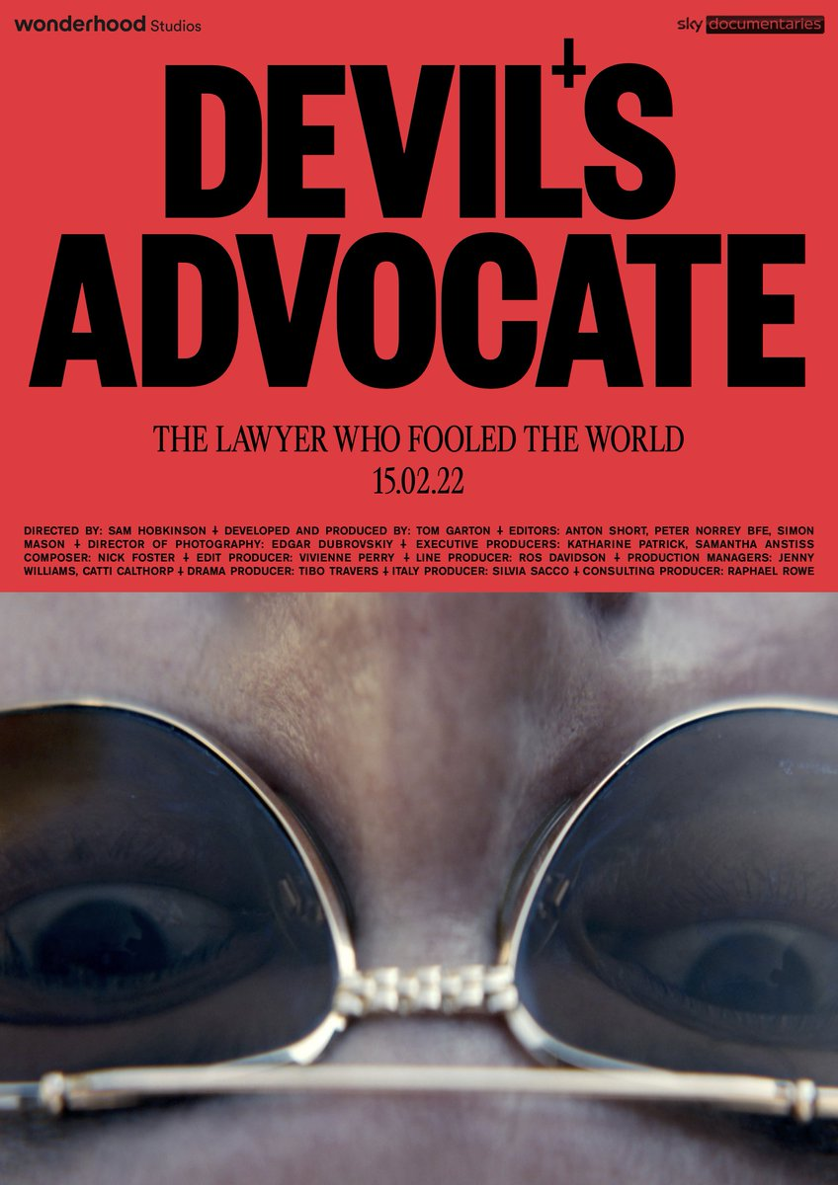

Another person who has influenced me is Louis Theroux this is because the manner and style in which he interviews people by asking the question and allowing them to speak about to gain their trust before asking more personal questions about the topic he is discussing with the interviewer. In addition to this, the way Theroux sets the scene through narration as well has inspired me as he is able to set the scene and what his documentary is about using a 1st person perspective an example of this is that he uses the terminology “I” a lot to make it sound more personal. Also, the camera effect of shaking as well as moving around a lot make Theroux documentaries feel more personal as well this can be seen in the documentary series forbidden America which sees him travel to America to explore the impact social media has on controversial topics in America.

Additionally, another person who has influenced me is director Ken Burns this is because of the Ken Burns affect which he uses in his documentaries this can be seen in his documentary Muhammad Ali in which the use of footage transitions between videos to still images/photos whilst being narrated over this adds the effect of a smooth transition to the documentary between a still and video footage. Furthermore, the reason why Ken Burns has influenced is because of the style of editing on the images themselves this can be seen in the documentary Muhammad Ali where the images that are on show in the documentary pan out or pan into the images themselves before showing the entire image. Ken Burns use of background music as well during the documentary brings an atmosphere to the documentary instead of it being background noise and the interviewer just talking throughout the documentary.