Documentaries examples:

Poetic documentary: Poetic documentaries focus on the use of imagery to show the audience a different view to what they would normally see an example of this is the documentary Olympia which focuses on the 1938 Olympics and uses imagery to showcase the event.

Expository documentary: Unlike poetic documentaries expository are made to inform or persuade the audience through narration an example of this can be seen in the documentary series planet earth which is narrated by David Attenborough informing people on nature.

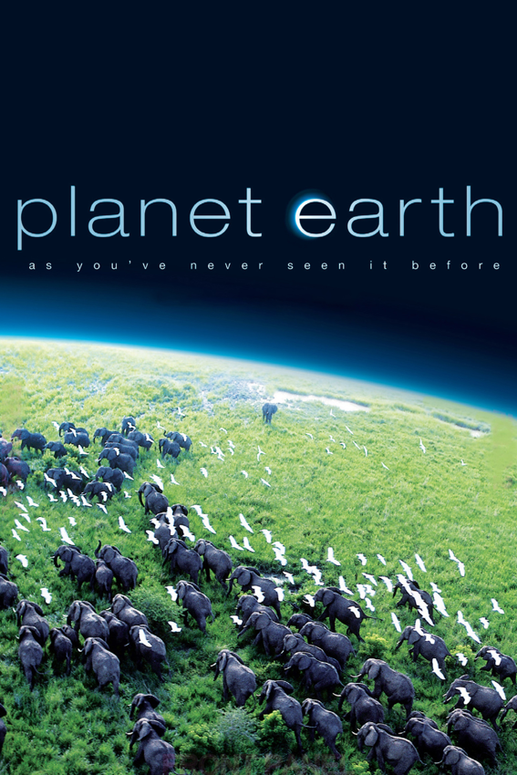

Observational documentaries: Observational documentaries like to get all sides to an issue i.e., different POVs to try and access more private information an example of this can be seen in the documentary young Plato which follows an Irish primary school head teacher who uses classical thinking to defuse an argument.

Participatory documentary: Participatory documentaries will include the film maker themselves in either a large role or a minor role even if it means narrating over the footage or even starring in the documentary. An example of this is the documentary Roger & me where the director conducts on – camera interviews.

Reflexive documentaries: reflexive documentaries are different to participatory in the sense that the film maker will only focus on themselves and not a different perspective an example of this can be seen in the documentary man with a movie camera which depicts urban life in Russia in 1929.

Performative documentaries: Performative documentaries are often made to share an emotional response with the audience. An example of this is seen in the documentary Paris is burning which focuses on drag queens living in New York city and their “house of culture”