This mood board is to show the inspiration that I got to inspire to do concept art for the final major project including illustrations from the likes of Ken Berthelmey and John Eaves.

References:

John Eaves concept artist [online website] available from:

<https://johneaves.webs.com/apps/photos/?page=1&&pagesize=36>& [Accessed 4th March 2022]

Ken Berthelmey portfolio work [Online website] available from:

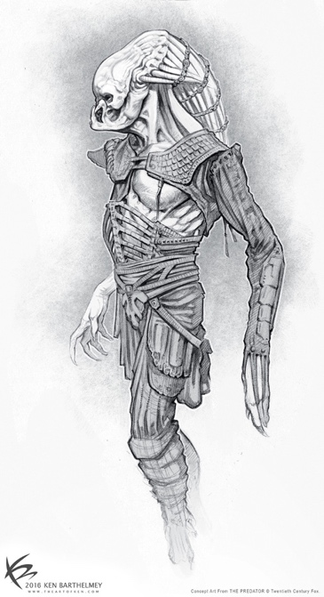<https://www.theartofken.com/gallery> [Accessed 4th March 2022]

