Game analysis

Doom eternal:

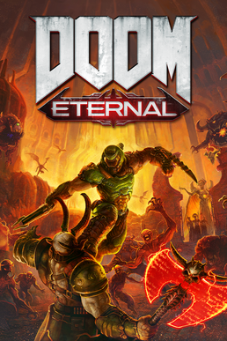

The reason why this game is good is because is because of the audio designer. The audio designer picked out music that is suited for the game for example the audio designer hired Mick Gordon to create a sound track that in places would be intense and in other places more subtle.

In addition to this, the particle affects within the game are so well done this includes the exaggerated effect of blood spurting from the enemy’s and the projectiles that are fired from the weapon. The cutscenes in this game are short and establish the point of game and who the main character is and why they are killing the enemies.

Also, the design of the enemies makes the player feel small when in the levels as they have been designed to make the player feel like an unstoppable force against the enemy. The concept artists have made the enemy’s look undead as the point of the game is to kill everything.