

Task 1

Please use the following questions to provide research on your own ideas on video games. This is a starter activity to develop your own current knowledge and further your understanding of the basics of video games. Please support your answers with constructive sentences, images/screen shots. Please upload your answers to Digital Space.

Please research and answer the following questions:

1. Do you play video games these days? How much time per week do you spend playing them? 30+ hours
2. Name 4 key features of a video game? Story, gameplay loop, graphics, and dialogue
3. What was the first game you ever played? Where and when did you play it? The first game I played was Simpsons hit and run
4. What type of video games are available for gamers (Give a minimum of 3 examples)? For each example, give a detailed description of them.

An example of the type of game available is run and gun an example of this is doom this is because the aim of the game is to keep moving and take out the enemies this is in part to the music picking up and the pace of the game getting faster encouraging the player to keep moving.

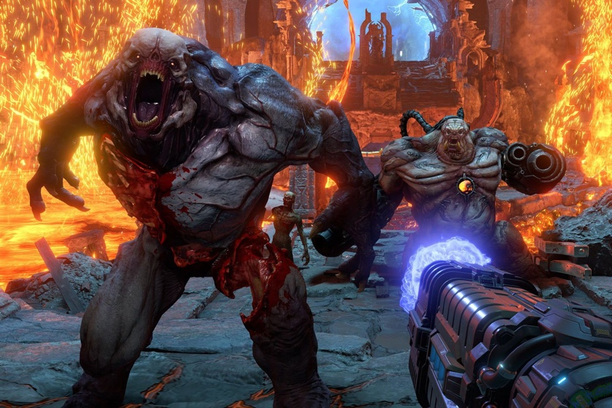

Another example of the type of video games available is grand strategy for example Stellaris this is because it places the player into creating a space empire and going fourth to develop their empire. This also means the player has to deal with the politics of other empires as well as colonizing other planets to gain more people. This type of game requires the player to think and also to not rush through as it can lead to consequences further down the line for example going to war with other empires.

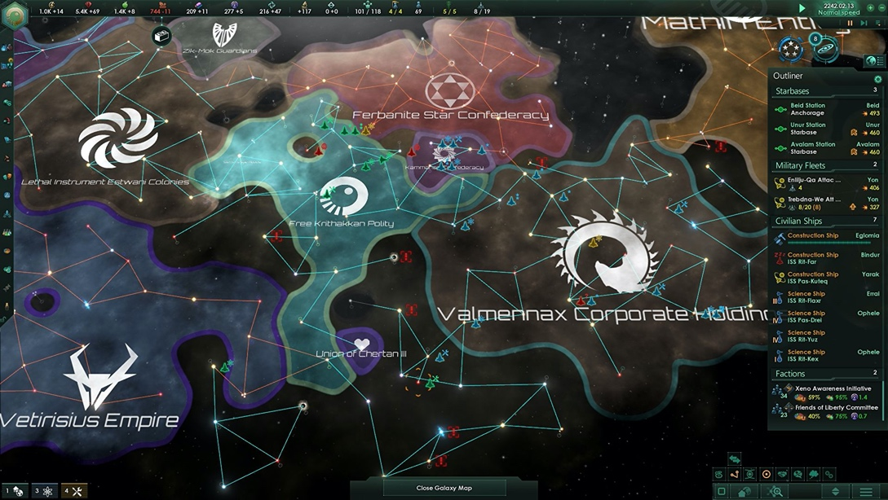

Another type of game is souls likes this type of game is designed to be difficult and a challenge for the player. This type of game will have difficult bosses and very limited health potions as well as a difficult checkpoint system and example of this is Sekiro this is because it has challenging enemies that require skill to defeat as well as a checkpoint system that will respawn enemies if the player wants to rest.

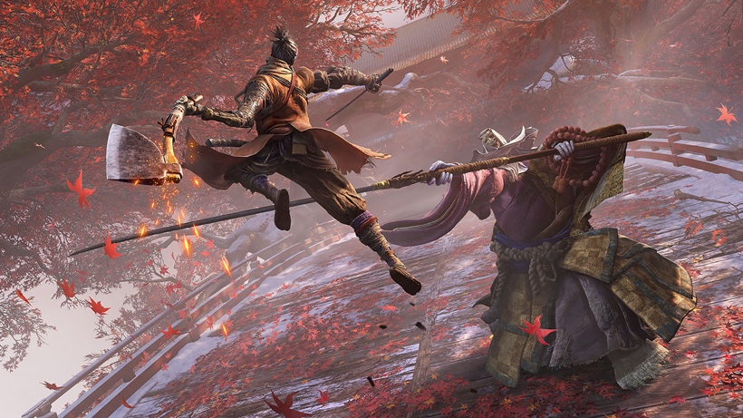

1. Children enjoy video games. How old should a child be before he or she is allowed to play video games? A child should be 10-13 years old before they can play video games this is because a lot of popular games out on the market are 18+ and nowadays there is kids who play it who are 10 years old and start to pick up language that others are saying within the game an example of this is call of duty this is because it is known for its toxic community and also language that kids don’t need to learn about.
2. Have you ever played a game that requires physical movement, like with the Nintendo Wii? What are the benefits of this kind of game? The benefits of playing a game that requires movement is that it helps people with their fitness an example of this is boneworks vr this is because it requires the user to use lots of movement whilst at the same time playing within the game.

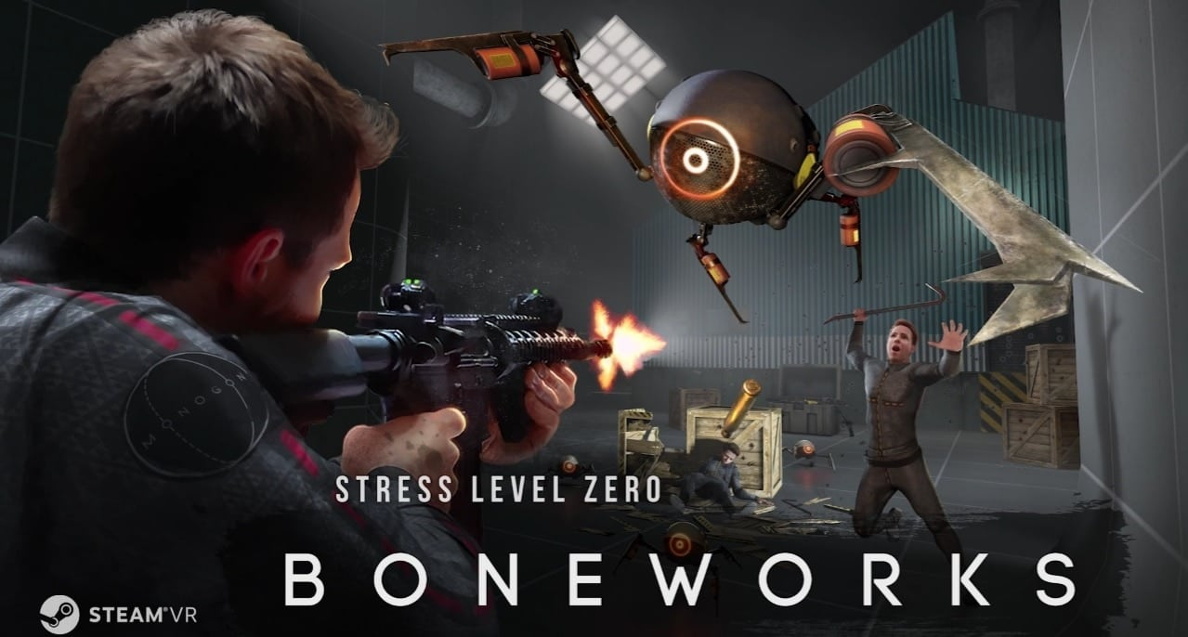

1. People play games on computers, phones, consoles and in arcades. On what kind of machine or device do you prefer to play a game? I prefer to play on PC this is because there is a wide variety of games for PC and a lot of the (Triple A) games tend to sell their games to PC users. In addition to this, the reason why I prefer to PC is because games look better being played on PC with the best setup compared to console.
2. What is your favorite all-time game? Why was it great? My favorite game of all time is dark souls this is because its challenging and requires skill to play that you don’t get in other games in this current market. In addition to the challenge of dying over and over again to the same boss once killed I gain a sense of satisfaction this is because it has taken me hours to try and kill it to then receive a reward for my efforts of hurling myself at a brick wall.

Some video games are very violent. Do you think they influence their players to be violent in real life? If so, what should we do about it? Are video games addictive? Why can't some people stop playing?

1. I think video games can influence their players this is because some players cannot control their emotions whilst playing video games an example of this is the battle royal genre this is because when some players lose, they don’t like the fact they have lost and end up throwing stuff and breaking stuff as well. In addition to this some people who play video games can be very easily influenced this means that they may copy the actions of a character or villain in a video game and act out in a violent way. Furthermore, their controversy surrounding this subject because in a report published by the BBC young gamers are needing help as they have become addicted to games and lash out at people who try to turn their console off. Also, this influences them as some have micro transactions in them and if they are younger and use their parent’s money it can become a problem as they demand for more money and may resort to being violent towards their parents.

Not only this but going on about the point of microtransactions some people will become addicted to gambling and would want to continue gambling to collect every piece of an item as well this in turn encourages people to become addicted to the game.

(I have linked both 9 and 10 in the same question)

1. It seems that most video game players are male. Why do boys like video games more than girls do?

The reason why boys like video games more than girls is because the (triple AAA) games target boys this is because it’s the theory that you have boys’ toys and you have girls’ toys as well as this the reason why boys are more of a target audience is because it’s the cost factor as well. The reason for the cost factor is because it would cost more to target a variety of a target audience for example boys and girls when the developers can target one area an example of this would call of duty and their target audience being teens and young adults.

In addition to this, the reason video games are targeted at boys more is because of the way a character is portrayed in the video games an example of this can be seen in games like call of duty and battlefield where the female characters are portrayed in a different view compared to the male counter parts and only in recent years have they brought both genders to more equal states. Furthermore, the gaming industry still sees that boys prefer to play heavy action and war types of games where as girls prefer to play “princess and make up” games this is also seen when they advertise their games as well to the target audience as the developers do not like to make a loss on a very popular game like call of duty or battlefield.

Reference

1. Are video games addictive? Why can't some people stop playing?
2. Some video games are very violent. Do you think they influence their players to be violent in real life? If so, what should we do about it? (This references links to both questions)

BBC report on gaming disorder published (22 December 2021) <https://www.bbc.co.uk/news/technology-59744569>