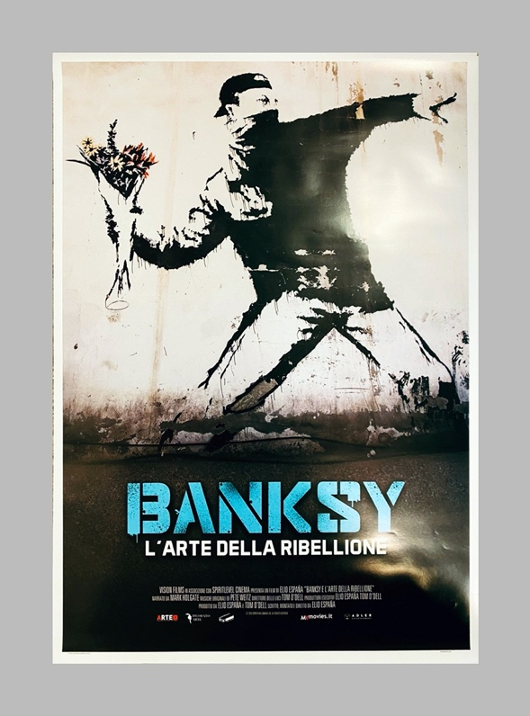The typography that is used for the poster is designed to look like it’s been sprayed by a graffiti artist. In addition to this, the colours give off a retro vibe as the person is sprayed in black and is been painted onto a white wall. Furthermore, the typography is in block letters with the letters all being in upper case to still continue the theme that it has been sprayed onto. Also, the posters give off the style that it wasn’t made by a professional but instead by an amateur this is because the blue text looks like its still dripping down the sheet. Continuing on with the style of the poster the poster also gives off the effect that it has been ripped directly off the wall as there is wear and tear that can be seen on the top right-hand corner.

This film poster use of imagery is intended to send a powerful message to the audience this is because the picture of the elephant on the left-hand side has an effect applied to the image that makes it look like the elephant is fading. In addition to this, the typography that is used for the poster is all in block letters this is also giving the effect that the text is made of ivory as there is cracks in the lettering and it is also bright white to stand out on the poster. Furthermore, the poster uses a dark background to give the effect that it is dark and that there is no hope for the animal as the effect that can be seen on the elephant almost merges with the background suggesting that this could be the last of its kind.