Final major project evaluation

Project brief:

For the project brief I was given the task of creating a project for the theme of incognito that would be shown at the Deershed festival for an audience of teenagers and young adults. This project will require me to apply my creative media knowledge and skills into making a project that revolves around the theme incognito and creating it to a good industry standard. The Deershed festival is a festival that is held each year with many people going to it as the festival revolves around technology and showing other people the different ways that technology can be used.

Idea concept and research:

The idea behind my concept for the theme incognito was to create graphics that would consist of multiple graphics including GIFs, posters, and a leaflet that would discuss the idea of mass surveillance within society. The idea of the concepts for the GIFs was to make it interactive for the audience as they would be able to scan a QR code to have access to these GIFs and use them throughout the festival. Another reason why I have chosen graphics is because the poster’s that I have created would be able to be located on the screens around the Deershed festival for multiple people to see an example of this would be shown on screens around the festival and also screens near the stage. Furthermore, the idea concept behind the leaflet was to create a leaflet that would discuss the pros and cons of mass surveillance with facts and statistics that would back up the discussion from reliable sources. This is because my target audience was teens and young adults the ‘google generation’ as they are more experienced with technology than adults and children. In addition to this, the reason why I have picked graphics for this project is because it will allow me to apply my knowledge and skills to the graphics that I have created from the past project as well as prior knowledge.

For the idea concept as well, I created a mood board to help me get a better idea of mass surveillance as well as influencers who inspired me to mass surveillance as the incognito theme for my final major project as seen below as well as different types of typography that inspired me to use the type of text that I used. Furthermore I also referenced research sources that I used in my leaflet to support my facts and statistics and also tutorials that I used to assist me in creating my graphics as seen below next to my mood board.

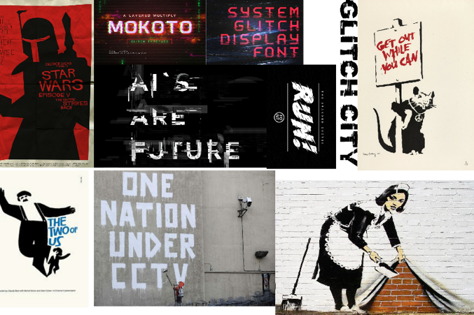

|  |
| --- |
| Proposed Research Sources & Bibliography (Harvard Referencing) |
| This link is to a tutorial on how to animate text:  Letsgettoit, (2017) glitch text animation [online video] Available from:  <https://m.youtube.com/watch?v=OVZrxaVLQ04> [Accessed 9th March 2021]    This link is to a webpage on how to create gifs using adobe Photoshop:  Adobe helpx (28th July 2020) create an animated gif from a series of photos [online]. Available from: <https://helpx.adobe.com/uk/photoshop/how-to/make-animated-gif.html> [Accessed 9th March 2021]    This link is to a webpage where I will get information and research from that will help me create my leaflet: bbc news (11th March 2021) Home office tests web-spying powers [online]. Available from: <https://www.bbc.co.uk/news/technology-56362170> [Accessed 11th March 2021]    This link is to a webpage of Saul Bass for my pitch: Famous Graphic Designers (2020) Saul Bass [Online]. Available from: <https://www.famousgraphicdesigners.org/saul-bass>  [Accessed 15th March 2021]    This link is to a webpage with facts that I will include in my leaflet: Platinum Asset protection (July 30th,2020) how many CCTV cameras are there in the UK? [Online]. Available from: <https://papltd.co.uk/how-many-cctv-cameras-are-there-in-the-uk/>  [Accessed 15th March 2021]    This link is to the webpage where I will create my personal QR code: QR code generator (2021) QR code generator [Online] Available from: <https://www.qr-code-generator.com/>  [Accessed 15th March 2021] |

Moreover, if I was to complete the project again, I would plan more effectively the time I allocate to the project and how much time I put into each section of my final major project (Poster, leaflet and GIFs). This is also because there would be times where something would arise and it would require my attention taking my focus away from the final major project and losing valuable time on the final major project.

Production and problem solving:

For the production of my final major project, I used adobe photoshop to help create the graphics for my poster and GIFs this is because I have prior knowledge on this application and also new techniques that I acquired from the last project. This included easier ways to crop images without the need of going around the entire image this in turn saved me time and allowed me to focus on the GIFs more to create them to a high standard and make them more visually appealing to the audience. However, a problem that I encountered during the production was creating a glitch affect typography to make the graphics more relatable to the theme this also made the graphics look more mysterious. To overcome this problem, I looked up tutorials online to guide me on how to create the effect on the text using adobe Photoshop.

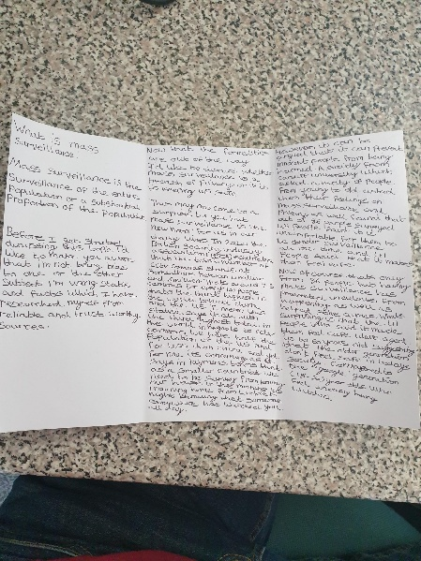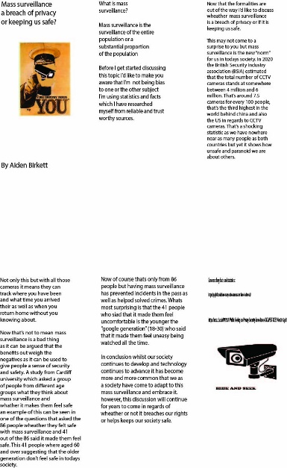For the production of my leaflet, I firstly created the leaflet by hand to plan what I was going to include in my leaflet for example how I was going to address the audience and also the layout of the leaflet. The problem I encountered with creating the leaflet by hand was that I was unable to include any of the graphics/pictures that I created into the leaflet. To overcome the problem that I encountered I used the hand drawn leaflet as a template and created the final leaflet using adobe Illustrator to include my graphics/pictures and to also make the final leaflet design to a good quality standard that people would be interested in reading and also for them to see my graphics that I have created. As seen below is my first draft of my leaflet as well as the finished design of my leaflet.

Furthermore, the production of the GIFs included me using adobe Photoshop to create the GIFs. The problem that I encountered with this is that I had no experience with creating GIFs and to overcome this problem I used adobe Photoshop forums to gain knowledge on how to create GIFs and to also find people explaining how to create simple GIFs that looked like a high-quality standard and that also looked professional as well. In addition to this, I also looked at YouTube videos to allow me to see how the user who is explaining it is creating the GIFs and also how to export the GIFs so that they work outside the application as I encountered a problem exporting the GIFs.

The skills that I have developed throughout the project is the skill of adobe Photoshop and now having the knowledge of being able to create GIFs using Photoshop. Also, I have also developed my skills in adobe Illustrator as well after creating the leaflet into a good quality standard. However, if I was given more time with the project, I would have been able to successfully create a QR code which would have been placed on the leaflet and be linked to the GIFs for my audience to download and use throughout the festival.

In conclusion, throughout the project I have developed new skills in creating GIFs and gaining that knowledge to help me follow through with my final major project and I have also overcome the problems that I encountered using different research techniques. For example, looking up tutorials online or going to online forums for help on developing my ideas and ways for me to overcome the problems and I am happy with the final project results.