Bot design review:

Bot 1:

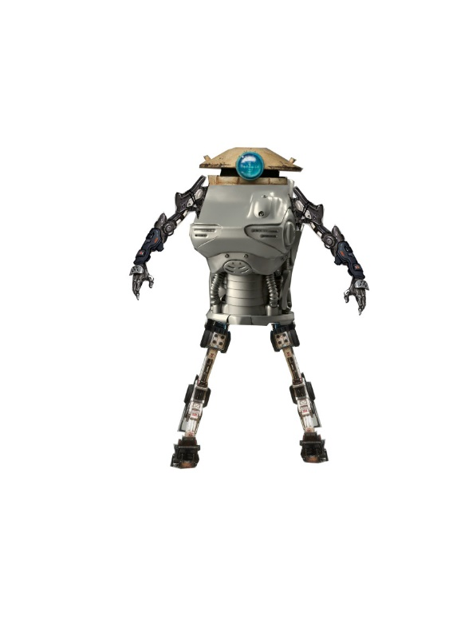

The ideas that went into this bot design was to have a bot that moved and had a body similar to a human an example of this is the chest of this bot would allow the bot to move like a human does. In addition to this the legs would also allow the robot to run and jump like a human. My thoughts behind this design was to design a bot that would look like a human and also if be able to use its hands and legs like a human would be able to for example the hands on this bot can be used to grab an object and use it.

Bot 2:

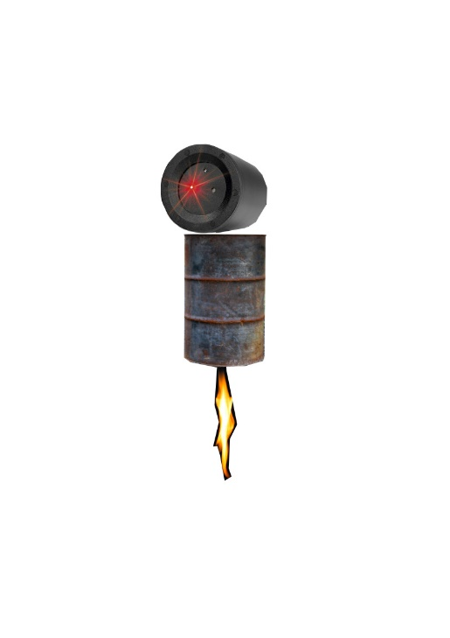

The idea that went into this bot design was to design a bot that would be like a moving surveillance camera/security system. This is because the bot has been designed with a thruster which allows it to move around the area and the camera that it uses to see things can be used to detect people within the area and relay them back to a security team. I got the idea for this bot from SC-fi movies and seeing bots that were used as cameras.

Summary:

The idea I got to design these 2 bots and in affect all my bots was from Sc-fi and futuristic games. In addition to this I also gathered research on three designers who created bots for games and took inspiration from there designs and also ideas to integrate them into my own bot that is unique and also had my own personal ideas put into the bot. Furthermore, I also produced 6 bot designs that allowed me to practice and improve my skills in Adobe photoshop by using the cropping technique and multiple images to crop out specific parts that I can integrate into my designs.