**Documentary proposal**

For my documentary there were two main documentary styles I could have gone for. One being observational where I could have portrayed both sides (developers vs players) of the point I am trying to portray and let the audience decide what they think but the more I researched the situation the harder it became to defend both sides as I don’t agree with the ‘cash grab nature’ of a lot of these companies. Therefor I have gone for expository where I aim to persuade my target audience that, there needs to be change in the industry and they have a lot more control than initially thought. My opinion will heavily impact the overall message of this documentary.

Although not every company falls into this category. For example, Elden ring is an amazing experience clearly filled with talent and passion. This game came out on the 25th of February 2022. So there is still magic in the industry. but when you compare an arguable master piece like Elden ring to that years call of duty vanguard released on November 5th 2021 there is a clear contrast of opinions between the two.

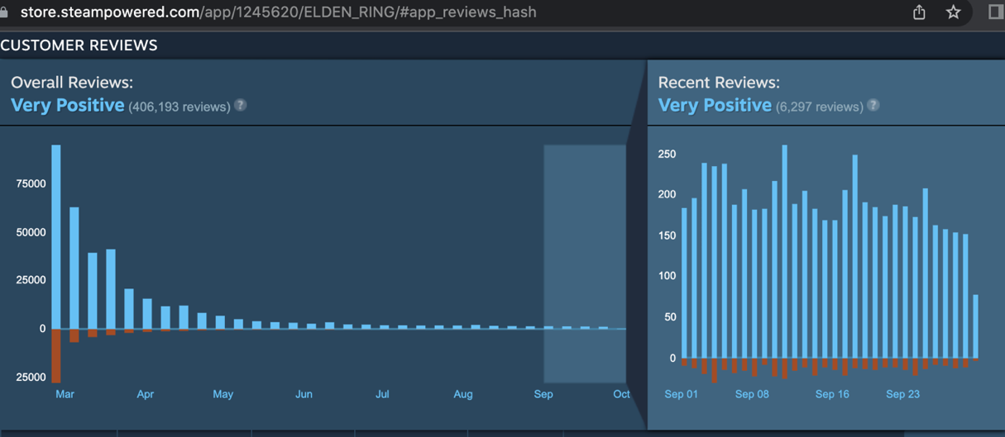

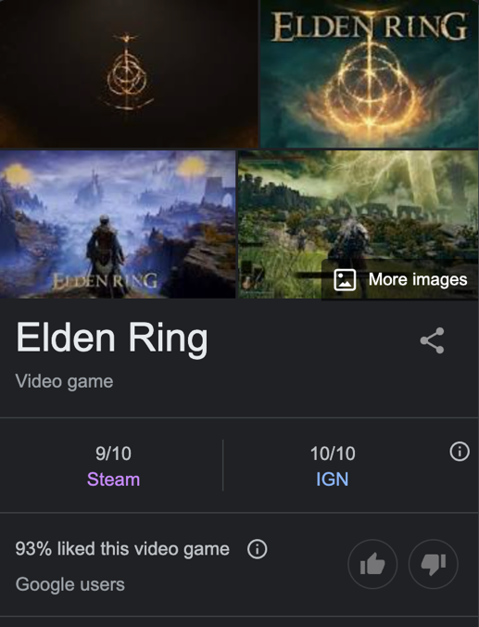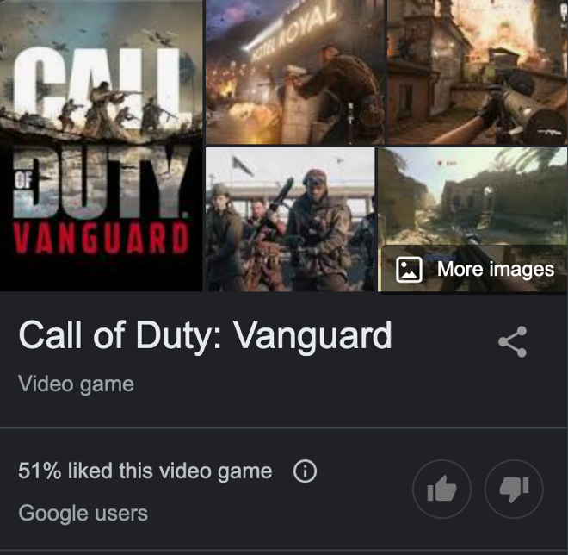

INNOVATION IN GAMES.

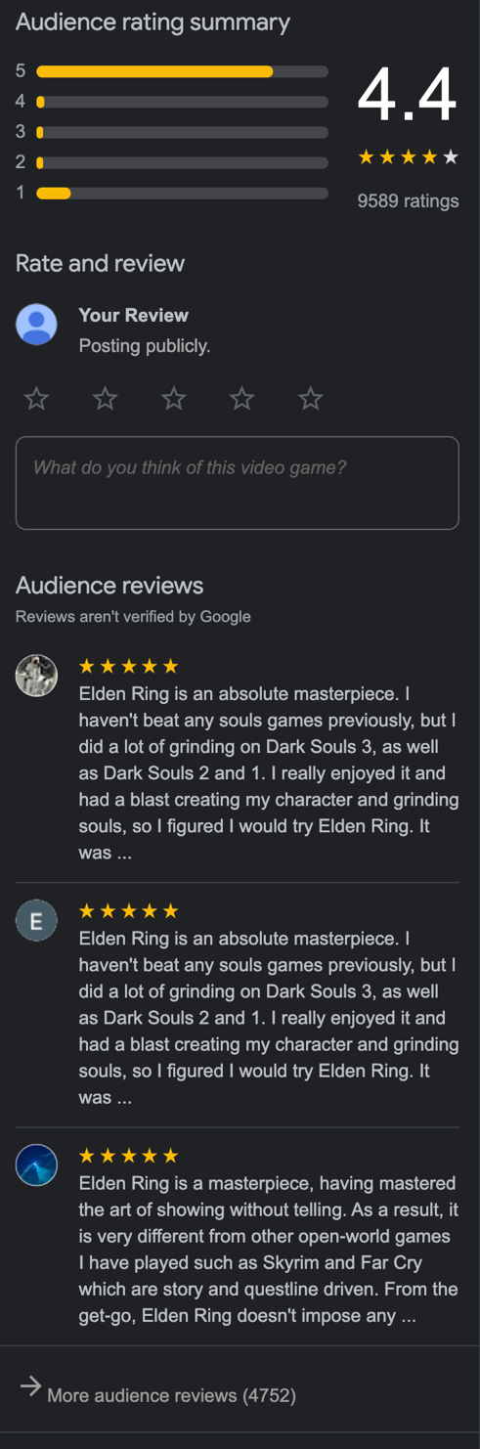

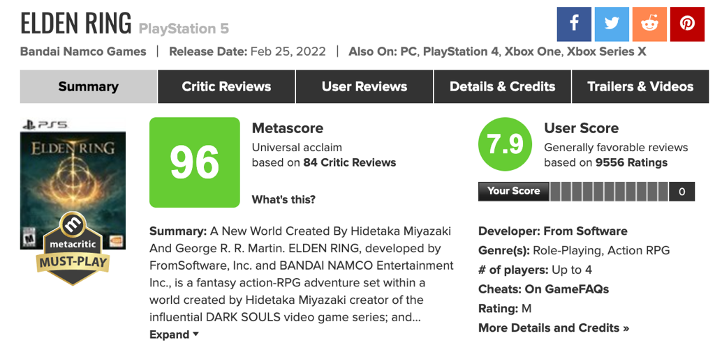



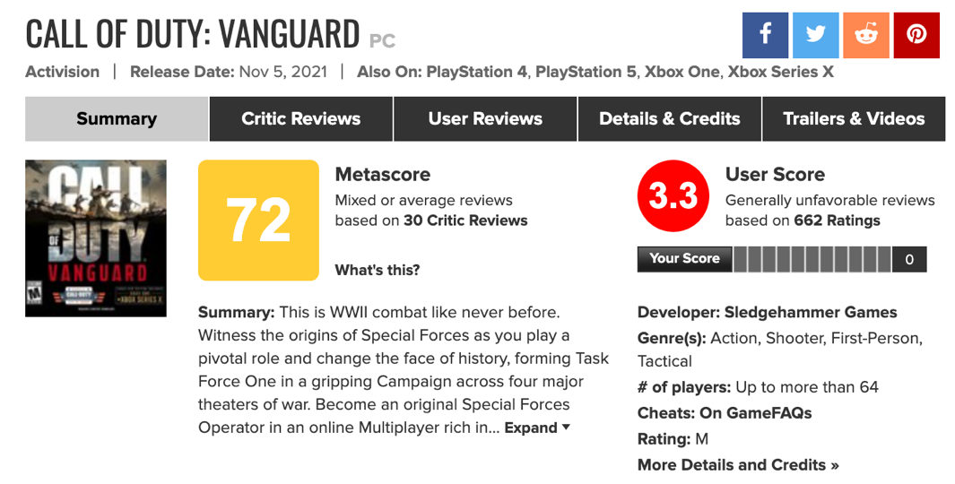



These reviews are from google and Metacritic and seem to reflect the same points with critics rating vanguard as an individual and users reviewing it as yet another soulless cash grab in its now 16th instalment in the game with a 17th confirmed to be coming on the 28th of October 2022. User reviews seem to describe the call of duty franchise as reskins with a lack of innovation. FIFA also falls into this exact same opinion with EA churning out half-baked yearly releases with little to no innovation or changes.

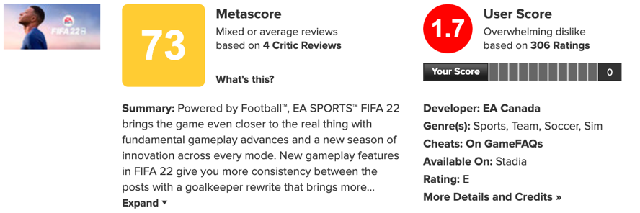



This was all quantative

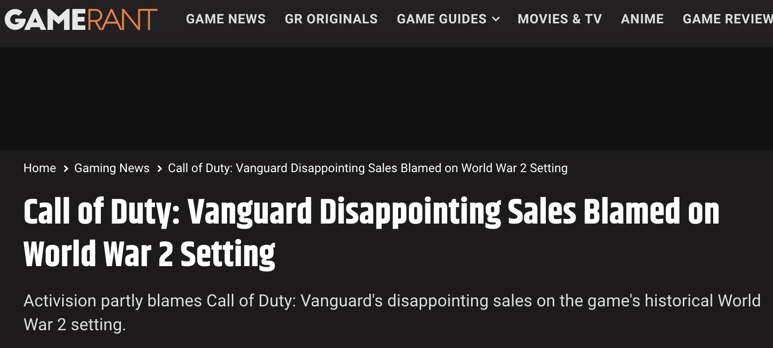Whereas Elden ring is praised for its brand-new open world map with amazing bosses and a less linear design all things that the player base was asking for. So, what is the main recurring theme that negative user reviews seem to bring up? Its arguably a lack of innovation so why is this? Well let’s see what the developers have to say.



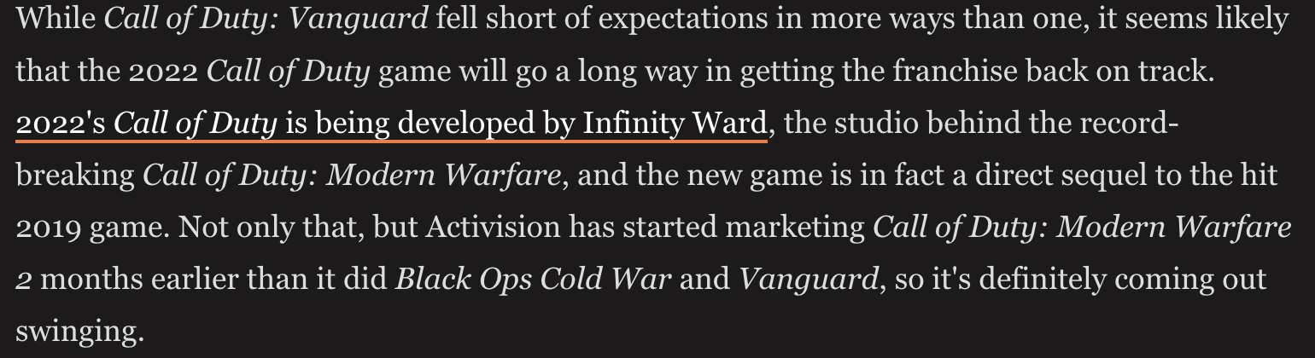

People can interpret this as a step forward but also the actual player base can interpret this a lie because they have said similar quotes every bad release. Although this is just qualitive (opinion)

https://gamerant.com/call-of-duty-vanguard-sales-world-war-2/

I will be targeting my documentary to the ‘hardcore’ player base of games in general. The people who have played video games as a hobby since as long as they can remember. To do this I will start off my documentary by establishing the time frame of which I would like to talk about. This being ps2 onwards. I will be going over what games were good across Xbox, pc and PlayStation. But most importantly what made these games good/fun and directly compare these to the games the mass player base plays today and go over pros and cons of both era of games.

To more directly target my intended audience, I will use the most popular games of each era in games and compare the two with why masses may really enjoy them whereas why my target audience may find them as stale and lacks innovation.

To reinforce my documentary type of expository, I will present an argument followed by evidence or an example. Ending with how it affected the industry and if it was negative or positive. If negative I will try to present an idea to help fix the issue. If positive I will point out how it should continue to be a part of the gaming industry and how it could potentially evolve into something negative or into something better.

To keep it a documentary and stop it from feeling like a YouTube video I will be doing interviews that argue both sides. For this I will interview the ‘casual’ player base with at least five questions that will build off of the last answer to keep it as close to their opinion as possible, and not get swayed by the way I fraise a question.

So, what is the point of this documentary and what is the message?

My point is, there is a larger casual player base for games that the developers listen to because this will generate more money where as the players that genuinely have a passion for games find them to be getting stale. This is because the developers will earn more with yearly releases because players will buy them regardless of innovation. So why should the developers put more effort in if they’re going to get similar if not greater results by what feels like copying and reskinning there most recent success?

I will be taking similar opinions from across the internet to not only get a general understanding where the problem lies but to also reinforce my point.

I will focus on 5 main games/franchises. These being call of duty, FIFA (although, other sports games have the exact same issues so I will talk about theses also), Fortnite and Elden ring.

I am focusing on these games because the first three fall into all the negativity in the industry. Although, fortnight has innovation it also started a domino effect that caused a negative affect across the industry.

Elden ring could have also released a copy and paste project like call of duty and FIFA. This would have required less work and like these other two franchises would have still earned them a lot of money. But they decided to put passion behind their product and has excelled far beyond what they would have, if they just took advantage of their fan base yearly like FIFA and Call of duty has done repeatably. For this reason, Elden ring will act as a positive comparison between the others.

My documentary will focus on innovation in games. There are multiple things people can mean when they mention ‘innovation’. The definition that I am going with is new and/or original. I am approaching innovation on a level of uniqueness.

Just because a game is similar to another doesn’t mean it ‘lacks innovation’. Out of my research a few people that have the same point of ‘a game lacks innovation’ seem to get innovation mixed up with genre.

For example, call of duty and battlefield are both first person shooters (fps). But these games have a huge contrast in fan bases. This is because they are drastically different games. Both games have the same base mechanics and are the same on paper, them being shoot the enemy more than the enemy shoots you and you win. But battlefield has open maps with vehicles like tanks cars and helicopters to obtain more of a war type experience. Whereas call of duty concentrates more on linear map design, reaction times and fast paced gameplay. These two differences alone keep the games from feeling the same.

Some may only see the first-person shooter aspect and not think to look deeper this is what I believe causes mislabelling a game with a lack of innovation.

In conclusion I aim to point out the lack of innovation in games that deserve the criticism. While also defending games/developers that get mislabelled as such.

I will also touch on dullness in games and who this affects. I will also go over the developers that lack innovation and their point of view…. slightly.

What do I aim to achieve?

Better communication between developers and players. But also, to receive better games.

<https://www.metacritic.com/game/playstation-5/call-of-duty-vanguard>

<https://www.metacritic.com/game/playstation-5/elden-ring>

<https://www.metacritic.com/game/pc/fifa-22>