**Six types of documentaries**

poetic: These types of documentaries focus on making the audience feel what is intended and are not always factual. An example of this is Terrence Mallick’s Voyage of film

. 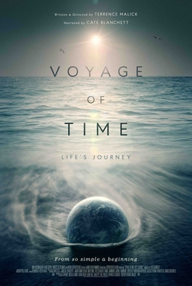

Expository: These types of documentaries aim to inform and/or persuade. Narration is devoid of ambiguous or poetic rhetoric. This is a straight forward and factual format.

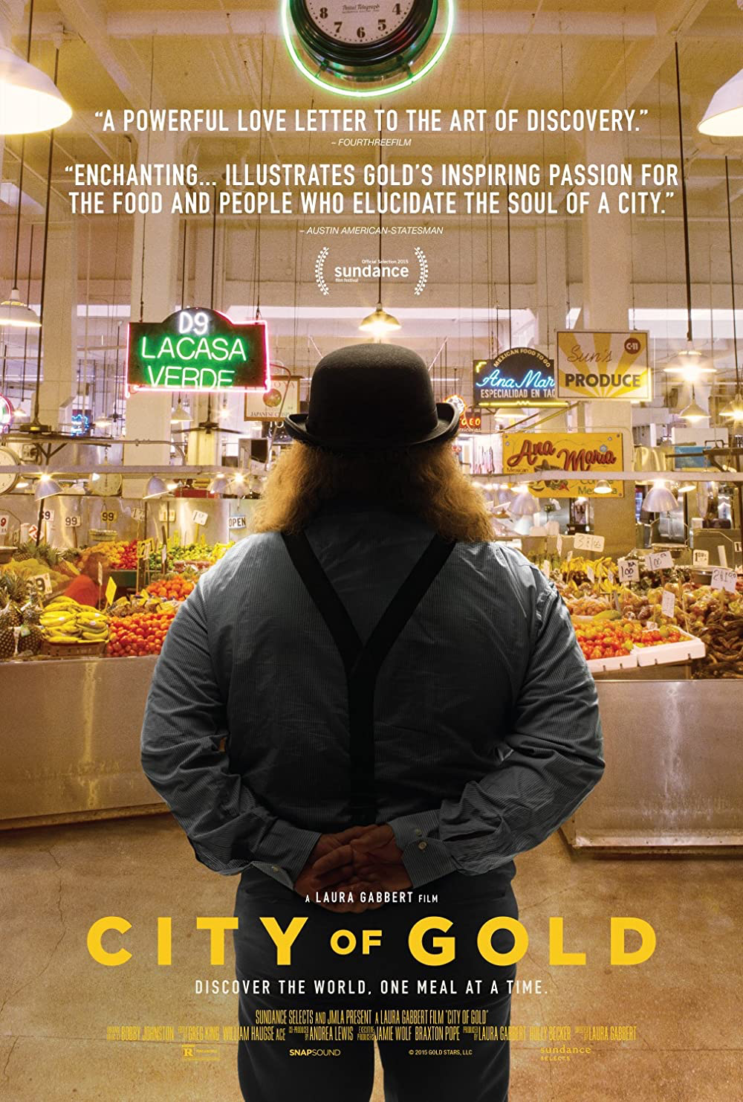

Observational: These types of documentaries aim to observe what’s happening around them. The aim is to give a voice to each side of an event and let the audience make their own mind up on the situation. In the room with JFK and RFK is an example of this type of documentary. 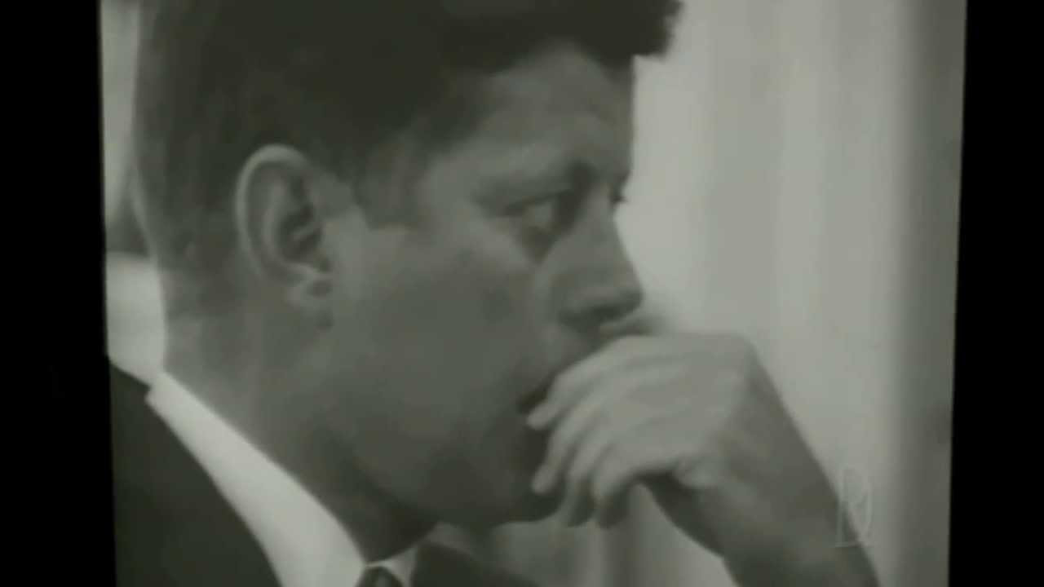

Participatory: These types of documentaries have a director that can intervene in questions asked and can either let them answer honestly or they will be told what to say. It is argued that all documentaries can be labelled as participatory. 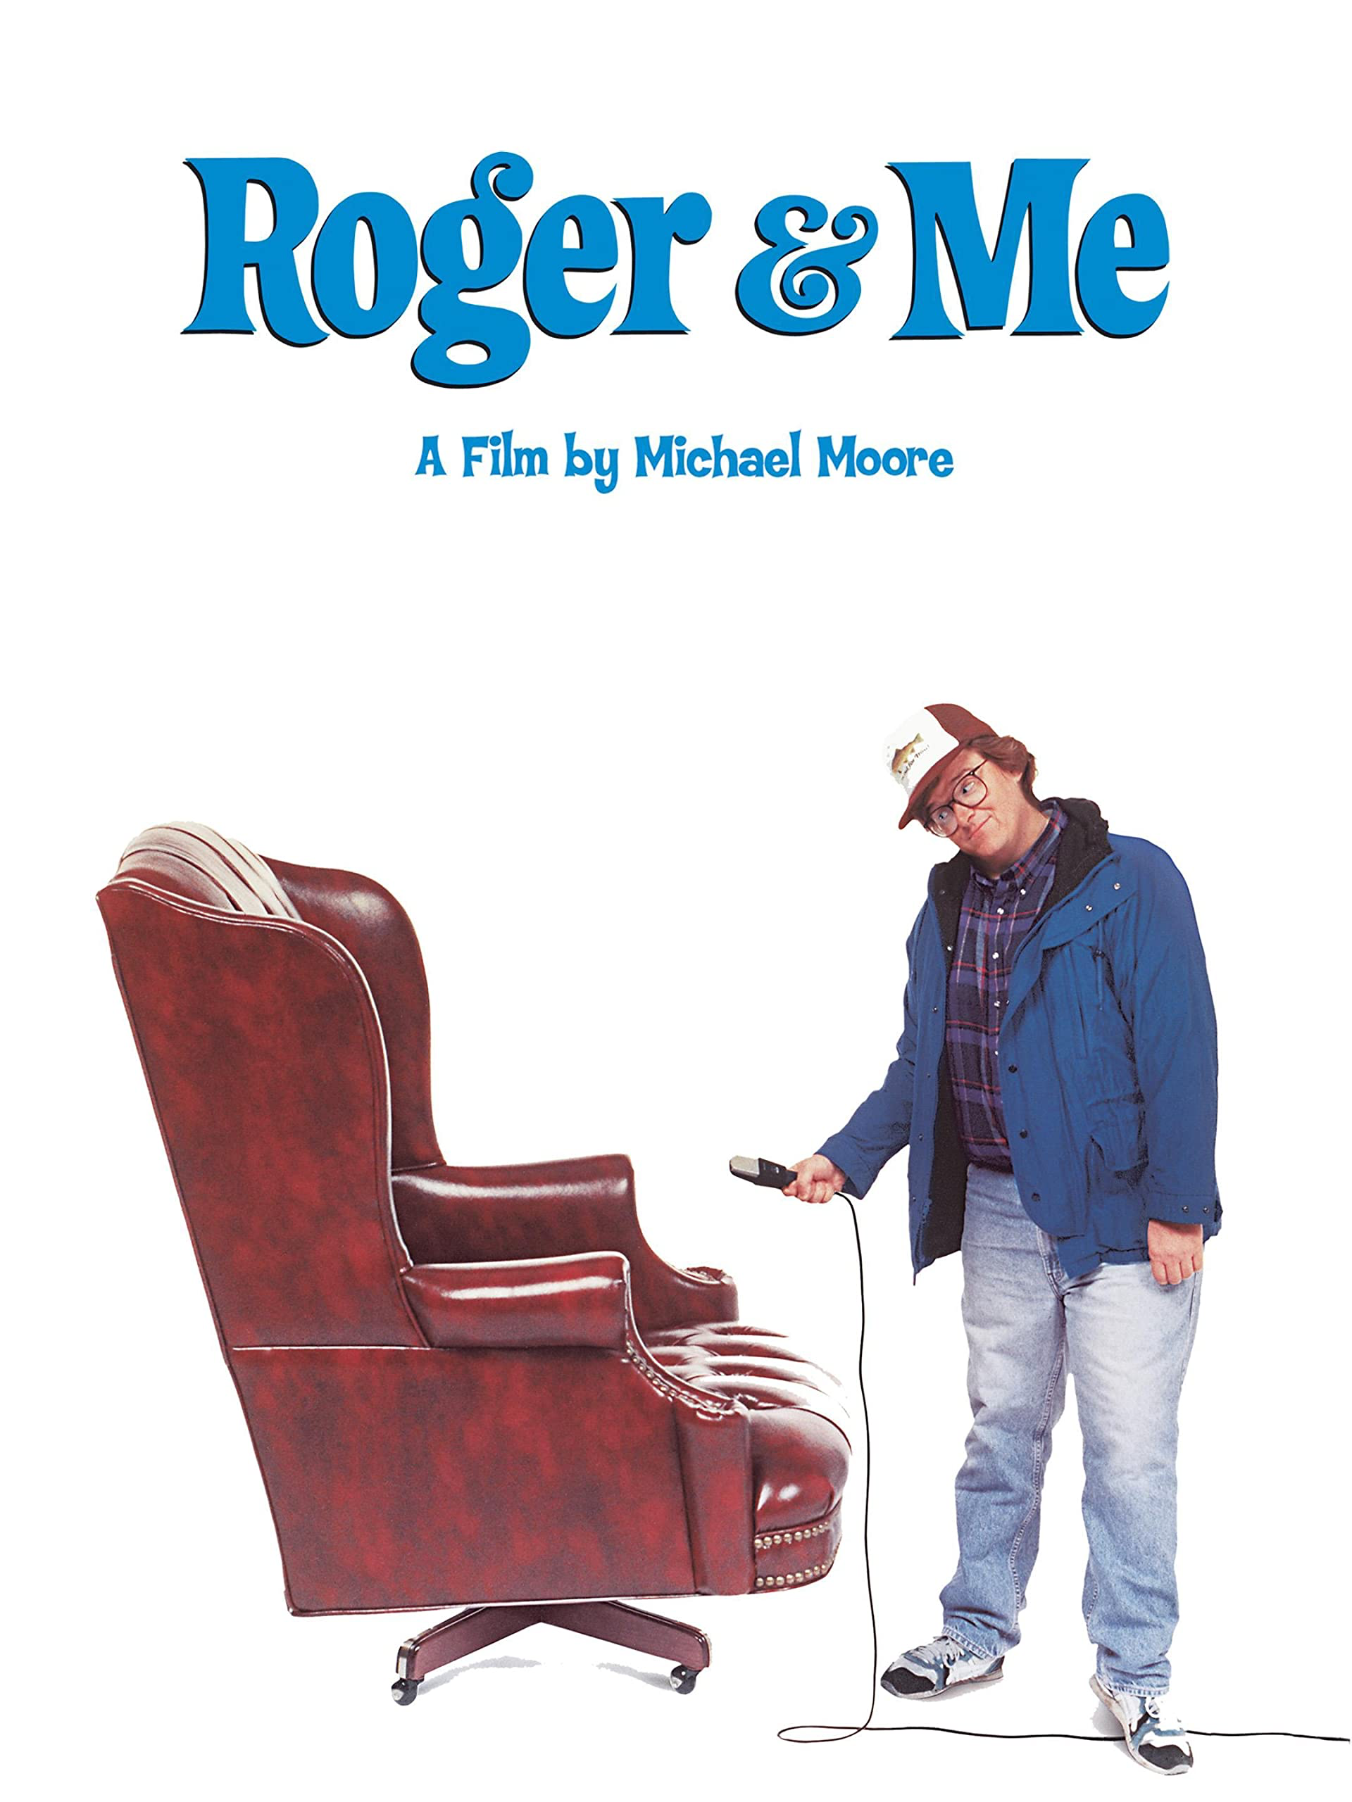

Reflexive: These types of documentaries also include a film maker but they don’t explore anything but themselves and the act of making a film. By this description bloopers and behind the scenes are a form of this type of documentary. <https://youtu.be/C3pEw4VFCI8> this is a link to a video of the example avenger’s infinity war

. 

Performative: These types of documentaries focus on larger political or historical events. As a way to share, educate and or manipulate an emotional response out of the audience. Bowing for columbine is a great example.

