**Documentary proposal**

For my documentary there were two main documentary styles I could have gone for. One being observational where I could have portrayed both sides (developers vs players) of the point I am trying to portray and let the audience decide what they think but the more I researched the situation the harder it became to defend both sides as I don’t agree with the ‘cash grab nature’ of a lot of these companies.

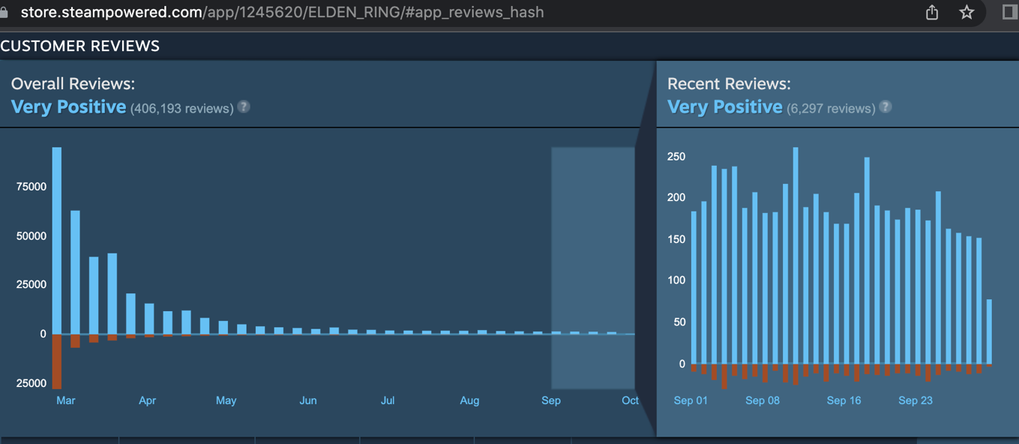Although not every company falls into this category. For example, Elden ring is an amazing experience clearly filled with talent and passion. This game came out on the 25th of February 2022. So there is still magic in the industry. but when you compare an arguable master piece like Elden ring to that years call of duty vanguard released on November 5th 2021 there is a clear contrast of opinions between the two.

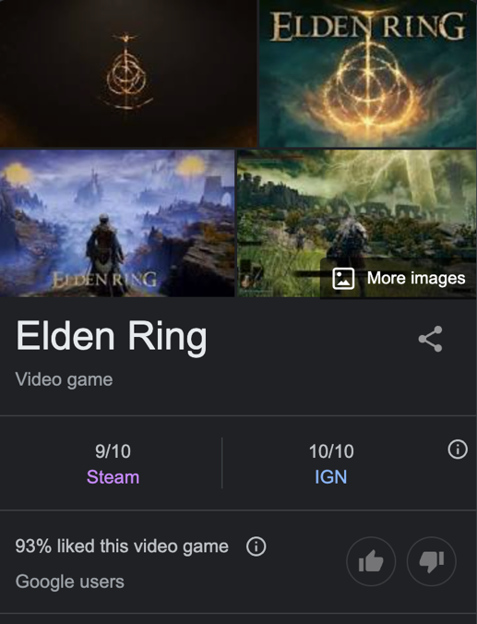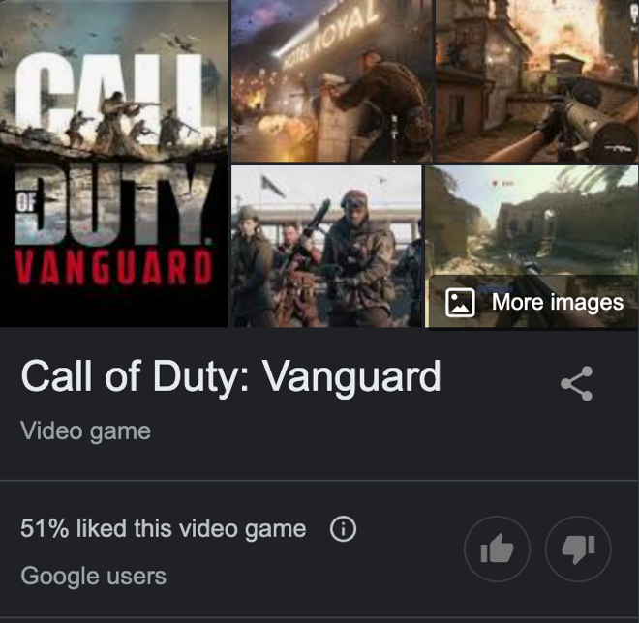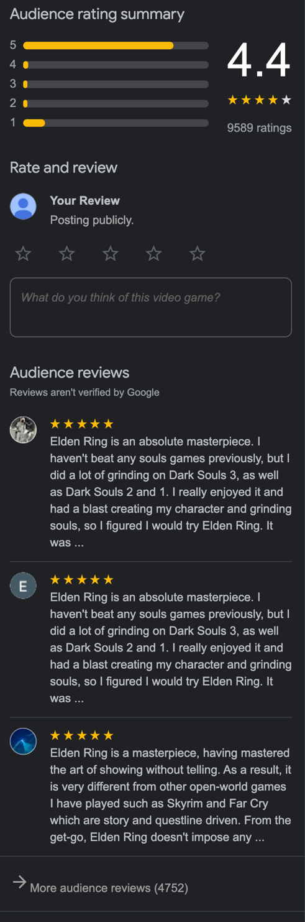

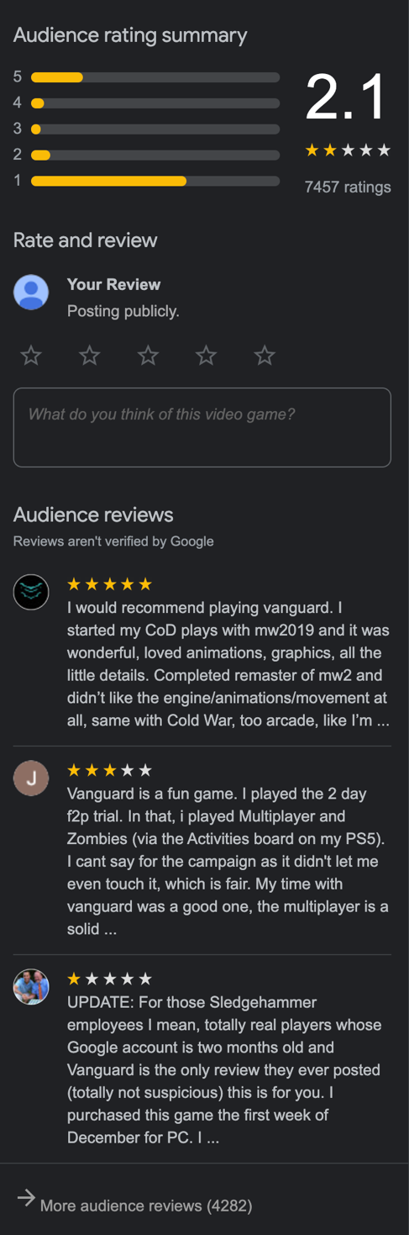

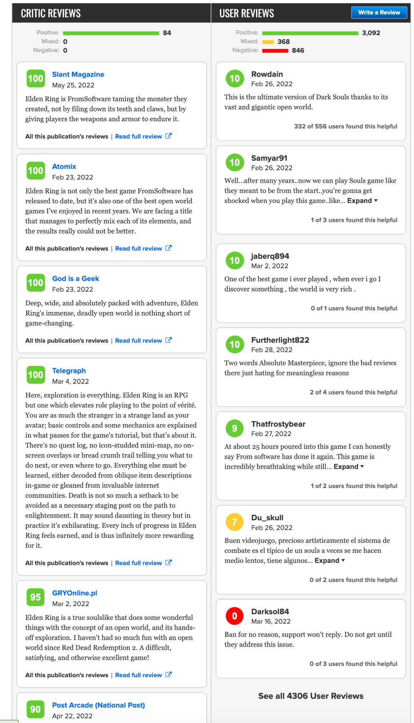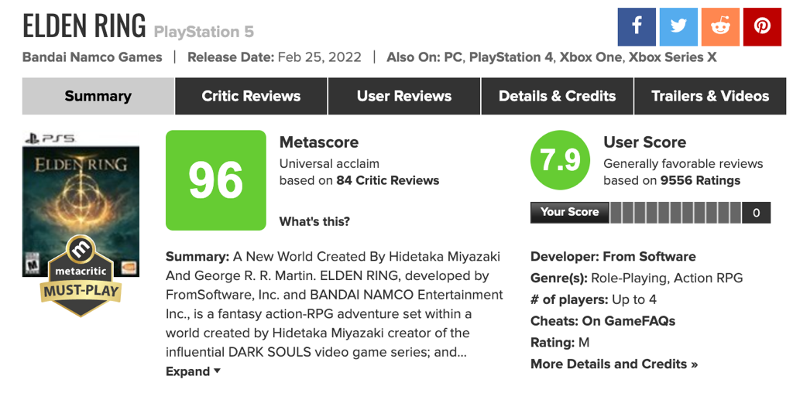

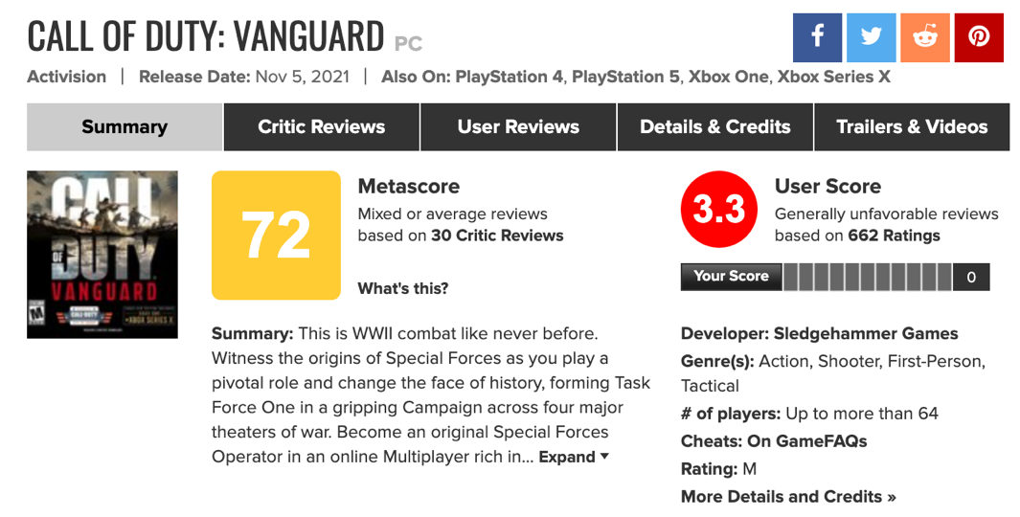

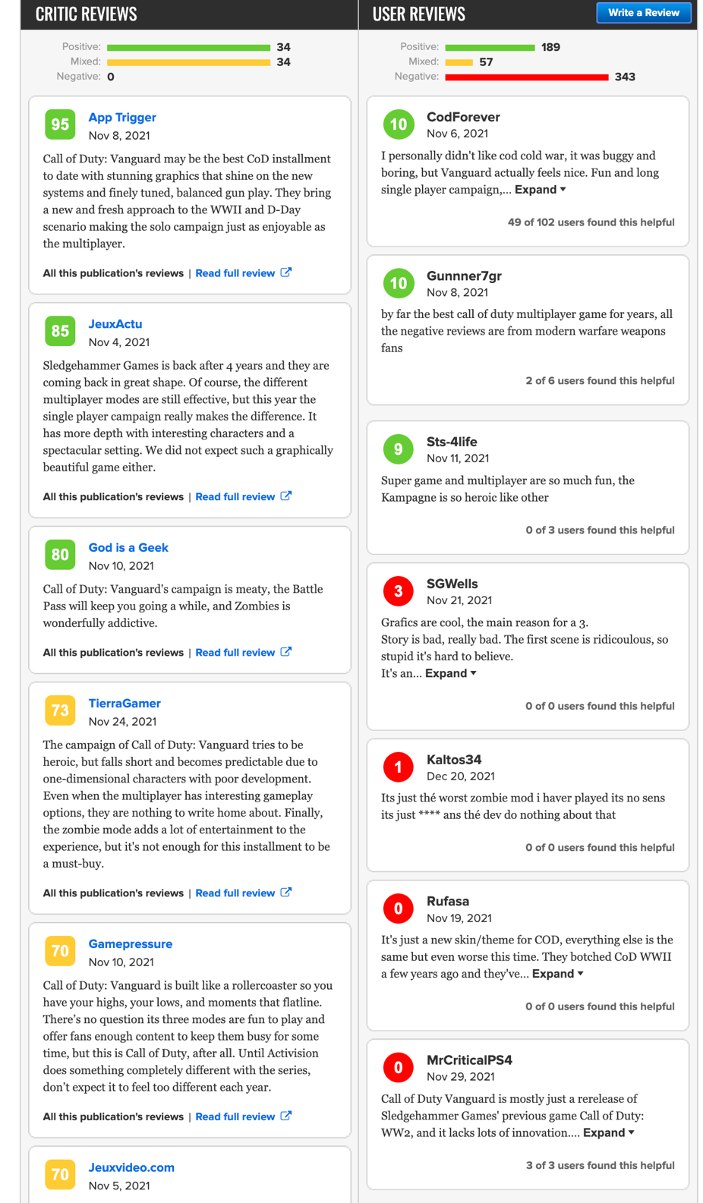

These reviews are from google and Metacritic and seem to reflect the same points with critics rating vanguard as an individual and users reviewing it as yet another soulless cash grab in its now 16th instalment in the game with a 17th confirmed to be coming on the 28th of October 2022. User reviews seem to describe the call of duty franchise as reskins with a lack of innovation. FIFA also falls into this exact same opinion with EA churning out half-baked yearly releases with little to no innovation or changes.

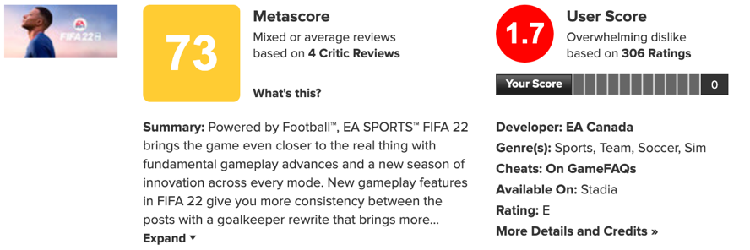

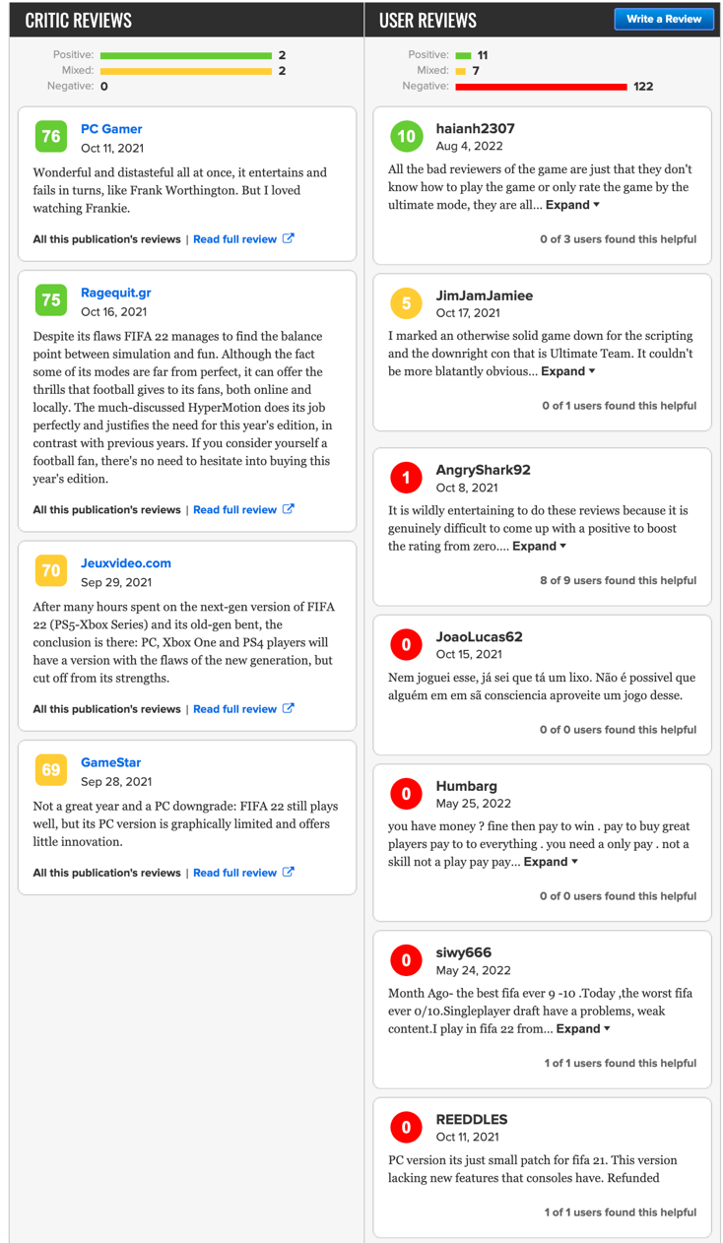

Whereas Elden ring is praised for its brand-new open world map with amazing bosses and a less linear design all things that the player base was asking for. So, what is the main recurring theme that negative user reviews seem to bring up? Its arguably a lack of innovation so why is this? Well let’s see what the developers have to say.

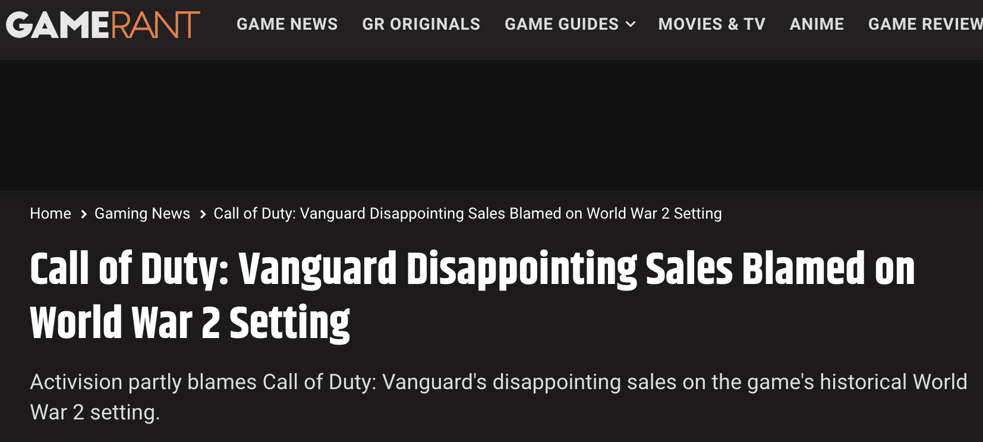

OH!

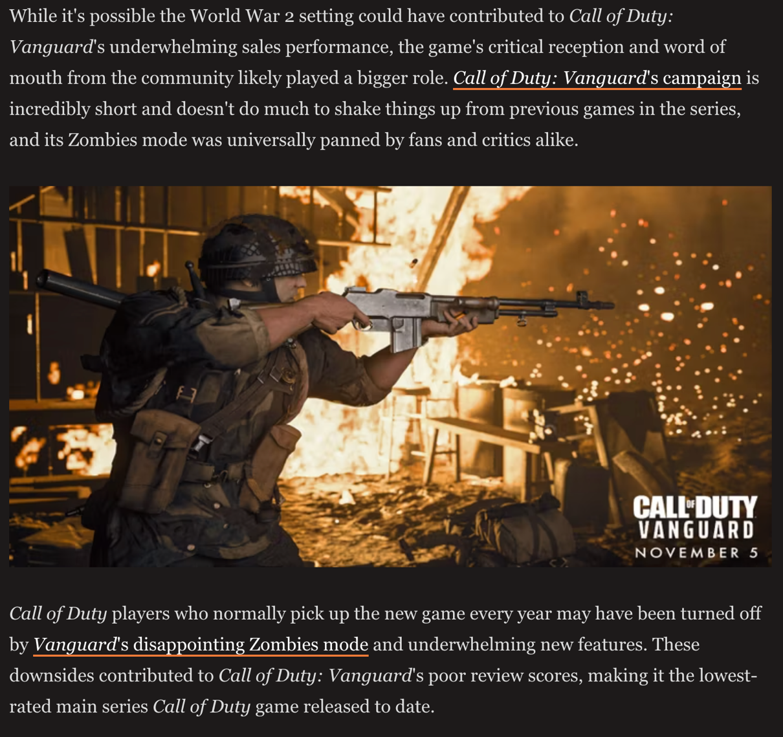

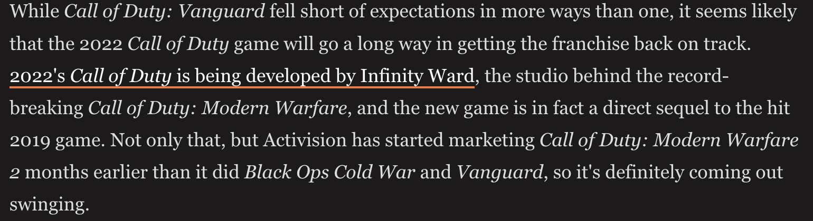

People can interpret this as either a step forward but also the actual player base can interpret this a lie because they have said similar quotes every bad release. For example….

Audience perception/Nostalgia

Argue the side of both (developers)

Hiding reviews? : took off steam and transferred to battle.net with no reviews at all!

Games. The staleness of games. Is It us or is it the greed of companies.

Research: other videos on the subject. Can use clips to portray the mass opinions on the subject.

Maybe some opinions on places like reddit

**I'm saying games are stale and cash grabs with little if any inspiration.**

