**Half way through**

I have managed to get multiple levels and a basic mechanic system for my top-down shooter. This is a list of problems to iron out at this stage.

Needs:

* Enemy AI- more specifically I need to find a way to stop enemies glitching through walls.
* Make levels more dense- by this I mean that I have to fill levels with more detail and assets to make the game feel livelier and more lived in.
* More items- at this stage I just have a health pick up but I need buffs and de-buffs.
* More guns- I intend to add a shot gun and an smg.
* 2 more basic levels and a boss fight- at this stage I only have three levels I intend to add a couple more and a boss fight to end the game.
* Main menu- I need to add a fully functioning main menu.
* A unique level (asteroids) type level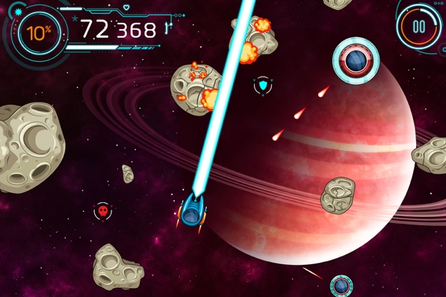
* All the sound from a backing track to weapons.
* Health bar- for the player
* Ammo count- I need to add an ammo counter and a reloading mechanic.
* A narrative to stitch the levels together.

I intend to have all this done by the 8th of may

If got time/can figure it out:

* Cut scene (for story)
* Inventory system
* More levels
* More enemy types
* Some chase levels

These are things that are extra but would add to the quality of the game.

* Must haves- functionality. I feel like most basic mechanics are fully functional.
* Should haves- boss fights. The game should have a variety in levels from settings to enemies. I need more settings, a boss fight and things like health bars and more pickups.
* Could haves- special levels. These could be essentially mini games in between each level to break the gameplay up.
* Would haves- more recourses, co-op. if I had longer and more knowledge with the software and how to make games in general the game over all would have been better with things like co-op more detailed levels and more mechanics like inventory systems and crafting.
* MoSCoW