**Project concept**

For my final major project, I will be making a top-down shooter game in construct two with assets and animations from pixel art and maybe photoshop with sounds and music that I make on garage band.

The concept of my game is loosely based around pocket planet. The pocket planet aspect of my game will be carried through with the story and settings in the game. A synopsis for my story is my main character scientist must find a way to teleport his whole galaxy out of the pocket of a higher being because said being is dying and when he does the galaxy will die alongside him.

Genre- sci-fi shooter

Type- top-down shooter

Level design- linear

Art style- pixel art

I expect to make five levels in total with one being a boss battle.

Each level will have hidden rooms, gun upgrades, buffs, nerfs and health pick-ups. Each level will consist of the player making his way through by killing a certain number of enemies to open multiple doors in the level until they reach the end. Each level will have a unique aspect. For example, harder enemies, hidden rooms/secrets and at least one mechanic added with each level passed.

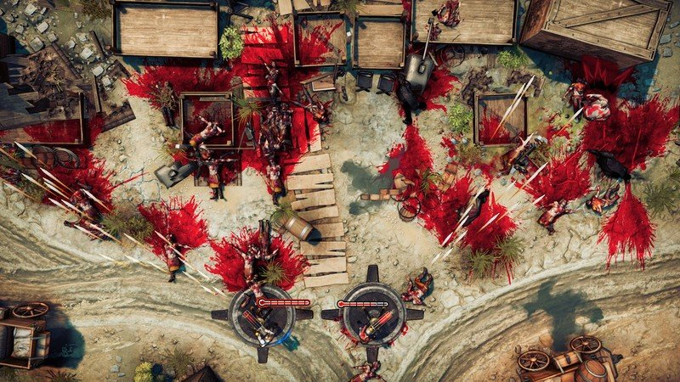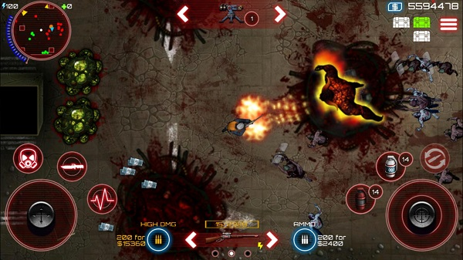 these images are examples of the type of game I am making for my fmp.