**Tom Clancy’s: Rainbow six siege**

Siege is a five versus five competitive shooter that has defenders protecting a bomb that the other team of attackers have to either defuse or take out the enemy team. The game started with a total of twenty operators (ten on each side) with their own unique abilities and guns to either aid the destruction or the protection of the bomb. As of today, there is a total of 62 operators split into two teams.

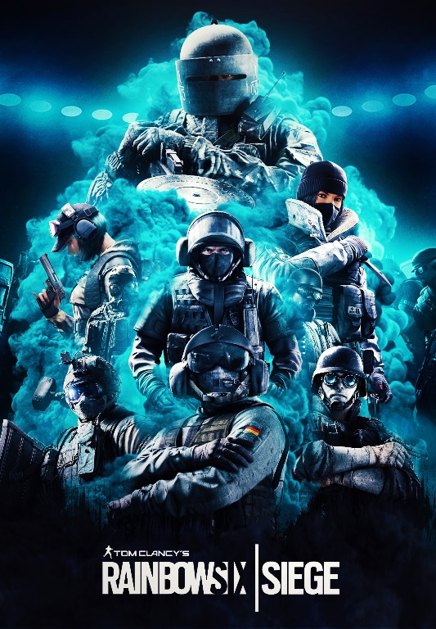siege has developed the strangest player base I have ever seen in any video game. It is devised of 80% of its player base feeling like bots because they say and play the same way every round of every game and scream down the mic when they lose one round and tend to want to pull up the stats of anyone on his team to shift blame where none where getting placed in the first place and if it was it was someone else as die hard as them. These types of players are what stop this game from reaching its full potential. This game has the biggest player base filled with back seat gamers for example, I used to play this game quite a lot and I stopped playing for a whole year due to the type of player I have just described because it got boring listening to the same 3 insults and excuses they have to why they lost a round that no one else cares about anyway. The other 20% of the player base are people who just like sieges mechanic’s and gameplay. This portion of the player base gets their experience hindranced by the other 80% from team mates team killing because you covered a pixel they didn’t want you to cover to not being able to play a casual game because you’re not playing exactly how they want you to. I feel like siege has the worst community I have had the displeasure of being a part of. When your team doesn’t want to assassinate you and the other team does not have one person to ruin the game as well the round starts yeyy, wait hit registration is terrible mainly due to the enemy team manipulating there ping to be able to shoot around a corner and kill you before the game even has a chance to show that they have moved. This wouldn’t matter all too much if there wasn’t a one-shot headshot mechanic which is the most inconsistent mechanic I have ever seen in any game. There is a peek mechanic which at some angles shows the enemy a whole chunk of your body without you even being able to see the end of their barrel. In conclusion it’s a broken game that is taken way too serious from a core player base that ruins the experience for new players and returning players that don’t play every day as most of them do. The game has the potential to be as frustrating as well as enjoyable due to a charm that only siege has the game mode is search and destroy with operators that have copy and past abilities on the same three to six maps but yet it feels unique and keeps me coming back (mainly to laugh at its embarrassing player base) to an overall FUN experience, something that games and players now adays put second.