**Target audiences**

There are 8 main demographics that make up a target audience them being age, gender, ethnicity, religion, level of education, occupation, income and family structure. Each one of these drastically changes things like a whole script and movie/tv show style, things like IRL, cartoon or animation.

A target audience is something that is decided in pre-production. A target audience will be decided by successfully following the main 8 demographics. This will determine the overall tone of a movie or tv show. First age is decided. There is a higher chance of the project being a cartoon/animation for younger audience we will consider this 3-6. Gender is then decided things like transformers, bob the builder and paw patrol all typically have boy audiences. Things like barbie, my little pony and the little mermaid all typically have girl audiences. Next on the list is ethnicity and religion which go hand in hand in many circumstances but not all. For example, someone that comes from a black ethnicity will find a comedy that takes their background and culture into account will find it a lot funnier than someone who does not know of their background will. Next level of education and income is taken into account a great example of this is shameless the target audience is clearly a medium and older audience that typically grew up in a poor area with an average education and what outsiders looking in would see as a bad ‘family structure’.

A movie/tv show for younger audiences (1-12) will and will not contain certain things. A movie/tv show will not have vulgar language or excessive violence because this is not deemed acceptable for children. Projects that target a younger audience tend to have a higher change of being a cartoon or animated so they can catch the eye of a younger audience with brighter colours and interesting animation styles. Making kids movie/tv show a cartoon also allows flexibility with non-violent fight scenes. A script written for a younger audience will not cover serious topics that are not deemed acceptable or will upset a younger audience. Therefore, most movies/tv shows targeting a younger audience cover things like friends, family and being nice and not divorce, politics or extreme racism.

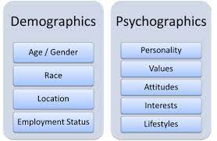

The Tv show ‘punisher’ has a target audience of male superhero fans but with marvel getting more and more mainstream they have accumulated quite a large secondary audience consisting of things like the primary audience’s friends and family.

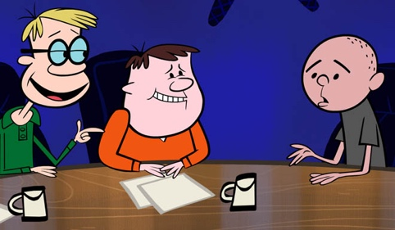 The Ricky Gervais show is a podcast but is also animated and laid out as a tv show. The podcast is rickey Gervais and Steve merchant asking Karl Pilkington questions, just sit and listen to him or pick on Karl. Karl tends to give funny replies. This is targeted to the average middle aged Yorkshire man. The secondary audience consists of all ages and backgrounds but primarily people from England

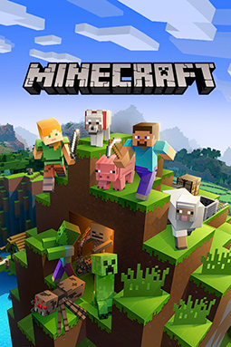

Minecraft is an adventure exploration crafting game targeted towards kids of both genders. The game has a simple gameplay loop and graphics however Minecraft has accumulated one of the biggest secondary audiences consisting of all ages, backgrounds and ethnicities.

Primary and secondary audiences….. hobbies…….job………

Geographics and phycographics. Tv show, podcast, game