**3 examples of game music**

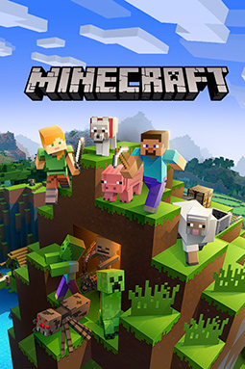 <https://youtu.be/wqRWXeWRdxk> This is a link to the Minecraft soundtrack, the first of which is the most popular. As you will be able to hear the music is calm and that’s because the game is targeted towards kids and can add to the game play and scenery.

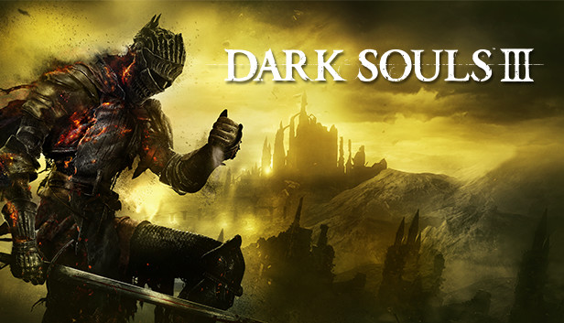

<https://youtu.be/JIT9aUHbcaI> This link is to the soundtrack of dark souls three. Dark souls three is the polar opposite to Minecraft and is intended for an older audience. The music reflects this.

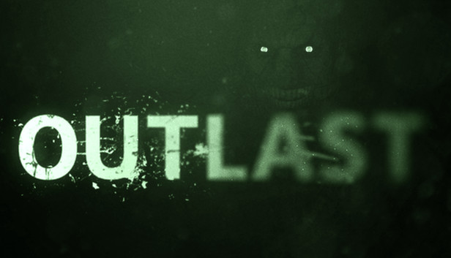

<https://youtu.be/r2r36ZqtidE> This soundtrack is very different because it is all horror music with the primary purpose to build suspense.