**Over-all production reflection**

My role in the production group was a cameraman, with this I didn’t expect to have to do much other than point the camera. However, getting an angle and the correct amount of zoom was challenging at first but became second nature as the production of splicer progressed. A lot of the time I found myself hafting to re-explain simple things throughout filming to the rest of the group. Things such as continuity checks and reminding the actors that they must be in the same positions in body and space. overall needing to give input or they seemed to become confused and stuck with how to progress shooting certain shots.

I came across numerous problems with how I composed each shot. Knowing loads of different ways to shoot but choosing which techniques to use that best fit each shot proved a challenge due to numerous reasons, things such as lighting and background noise all had to be considered but not leaving it too dark so it's impossible to see. I found that when I would give an idea or some off comment that I thought would add to production I would often be ignored in which then someone else repeats what I said, and they treated it like a new idea. For example, the scooby-doo jump was suggested earlier in the production as an off comment as an alternative to the dialogue that I didn’t agree with. ‘It’s funny because menstrual cycles’ was the only scene where the rest of the group considered the ‘comedy’ aspect of the short film up till this point. Credit is not the problem here. The problem is that I was ignored in many aspects of the short film for what seemed like no reason. This causes writing a reflection to be difficult because other than the beginning POV shots and a couple in the hallway scene I didn’t get as much of a hand on experience that I would have hoped for. The director often didn’t come in after the initial shooting resulting in me and the editor to have to fix the beginning of the movie without the director. On one of the shootings slots the director unnecessarily printed a script that took 40 minutes from that production session. I spent this time familiarising myself with the camera and lining up the end shots that contain the overhead red light and I showed some of the actors. I had to leave later in this session a little earlier than normal, and the same shots were still used.

When postproduction came along (editing) the editor found it hard to find music that we had access to that also best fit splicer. As a result, I am very disappointed with the music that was used but this was not a fault of the editor this was fault of the content that we have access to.

The original opening shot was a boring mid-sot of the two main characters putting multiple items (that made no sense) into a backpack and leaving for the party by walking towards and past the camera. The entire time I told the group that we needed to do the whole scene with tree different shots one mid and one closeup on both the main actors and don’t forget about continuity. The group then ignored me and shot the whole thing in one boring mid shot. This whole scene was then re-shot and replaced by me and the editor after the feedback came back that it made no sense, and it was boring. The scene that replaced it is shot as found footage of the previous victims walking though the scene of previous victim’s blood showing that there has been even more victims and I also added a small aspect of where the short film is set. I shot the POV shot with a constant intentional shake to show the fear in the victims that were making their way through. I also shot this scene like this to try build tension. This shot was then ruined in post-production due to the limited music we had access to.

For my future projects I could learn different shots such as a Dutch angle Aswell as high and low angles to do things such as show who has power from scene to scene. I could also implement some shots that I have taken inspiration from other forms of media. [The Matrix Behind The Scenes - Rooftop (1999) - Keanu Reeves Movie HD](https://youtu.be/Kjcv-JtUOgA)

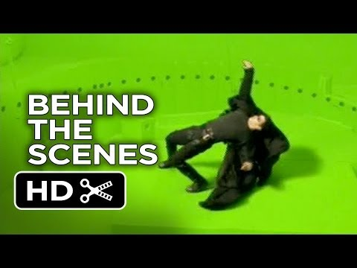

This is a video for example. This is the rooftop fight scene and there was interesting camera work done throughout the whole scene but most noticeably the bullet dodging segment fourth seconds in. This is the type of shot I would like to aim to implement in furure projects.

[Avengers Endgame Without the VFX / Amazing VFX Breakdown](https://youtu.be/NTc1VwnY-EA)

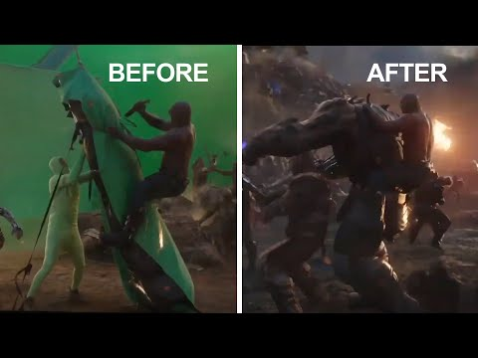

This is a quick video showing key VFX in avengers' endgame and how they use their green screen. I would like to implement some form of green screen in my future projects weather that will be for an off scene or for a short film set in space for example.

[The Punisher Prison fight Scene (Daredevil Season 2)](https://youtu.be/0MHJHkA6LMk)

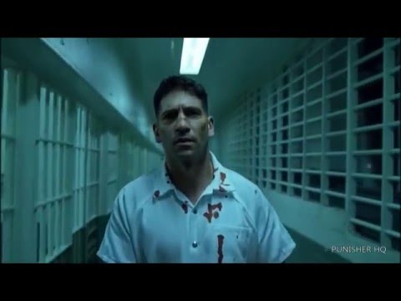

This is a great fight scene from the TV show daredevil. This fight scene is entertaining to watch due to the pure believable violence from how the fight choreography is shot to make each punch look more impactful, to the sound design to make each noise sound realistic and more believable to immerse the audience in a bloody fight scene. I would like to implement gore and or violence in furure projects through fight and other scenes.

In conclusion I feel like I did ok camera work and need to vastly improve in shot variety and symbolic meaning in shots. For example, things like foreshadowing and how long a shot should linger to give meaning to things such as objects or characters. I could also use camera work in shots to entirely drive a narrative. For example, weather a shot is continuous or not can entirely change the tone of a scene whereas flashy camera work can also take away from the narrative and distract the audience from things such as plot and continuity. I feel like not everyone got the same learning opportunities due to lack of things to do unless you were a director or actor while filming. I feel like my work would have been a lot better to present if I was in the director role just because I would have a lot more done to reflect on.