First-person shooter

Age target audience- 12+ (male)

The game is set in the year 2100 where radioactive bugs are genetically altered to listen and attack at the command of a mysterious figure. This figure kidnaps the main character to experiment with the obedience and the strength of the super bugs. The main characters aim is to survive the onslaught and deal with this mysterious figure. This figure is revealed to be a bug human hybrid. The game ends with the main character not being able to go back to his normal life due to alterations to his DNA that turns him into a similar creature to the villain. During the boss fight with this villain the main character learns of his back story.

**Game mechanics**

There will be general weapons that the mysterious figures will leave you to push the limits of there bugs. Weapons will start off as week and will gradually increase in power as the strength of the bugs do. The player will start off with melee weapons like a rusty knife and will earn things like guns and swords in which you can either upgrade and keep one liked weapon or switch with weapons placed in the arena. There will be a jump mechanic. Maybe a climb mechanic where the player can latch on to large enough bugs. Spiders will act as a group and there will always be a queen present for every other 100 spiders. There will be defensive and offensive bugs, for example. Beetles will be hard armoured and hitting but slow moving. A wasp will be fast and do high damage but will be weak. Spiders will be weak but fast. Flies will be a common enemy type mixed with other enemies and are the weakest. A praying mantis would be a boss fight. The player will upgrade weapons with the venom and blood from slayed bugs. By the end of the game the main character will begin to turn weak and collapse. As he wakes up he notices that he has grown fly wings a wasp stinger and an ability to also control low level bugs. After the game is finished the player will be able to go back a play each level with the upgrades that they earned throughout the game so like a new game plus. There can also be a horde mode unlocked after the main game is complete.

The game levels are set in this giant underground system under the main villain’s mansion where he has been breeding the bugs. This will allow the main character to fight his way through and up to the main house where the main villain will be. As the character fights through there will be drawings of bugs with an alias of each scattered around giving the player the back story to each bug in an intel form.

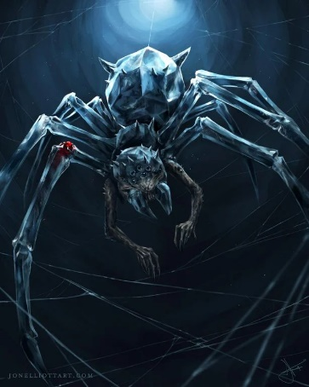**The spider queen: she will have the ability to:**

* command soldier status spiders.
* Stick the player in a spat web.
* Add a slow effect after bite attacks
* She will have crush and smother, she will grab and squeeze She will have
* She will have impaled, she will stab with her razor-sharp front legs.

**Soldier spiders: these will have the ability to:**

* 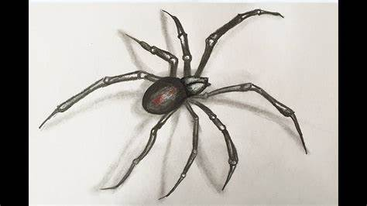 Pounce. This will be a low damage common attack that the player will have to spam a button to get them off.
* Venom spit. They will spit venom that will leach on the players health.

**Beetles: these will have the ability to:**

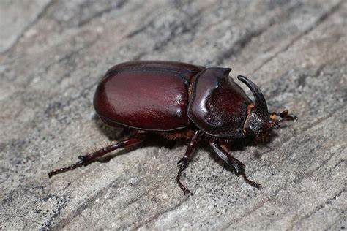

* dash. This will be the fastest attack he has but will still be slow. But will do high damage.
* Flight slam. The beetle will fly up into the air and slam down on the player.

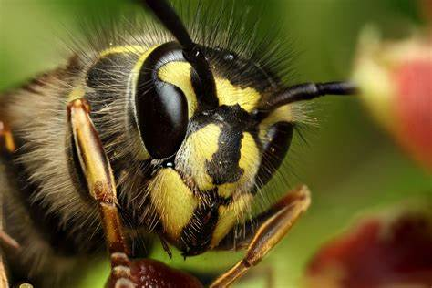**queen wasp: she will have the ability to:**

* Fly. This will be a passive
* Sting. She will be able to sting the player but only while on the ground
* Flight sting. This will be a sting dash that will instantly kill the player but will be telegraphed
* Wasp bite. This will slow the player making it harder to dodge flight sting.
* She will also be able to control the wasp drones. Buzz buzz

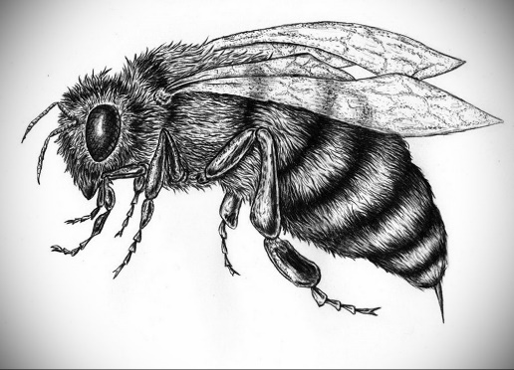**wasp drone: these will be able to:**

* Stinger shank. The wasp will latch onto the player and sting till the player spams a button to get them off.
* Flying headbutt. The wasp will dash and stun the player

**Infected fly: these will be able to:**

* 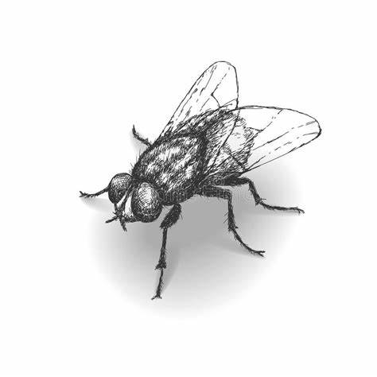molten vomit, this will be an infectious attack that will leach health off the player.
* Dash this will stun the player. +